**AB Testing**

**Short summary:**

1. Understand the change that you want to implement. What are the choices? How did we come up with those?
2. Start with high level business metric followed by detailed metric related to user experience
   1. You might have to come up with a proxy metric for difficult metrics:
      1. Example – Probability of finding information via search: Possible proxies – Time spent, clicks on results, follow up queries
   2. If there are multiple metrics that you are tracking then you would probably want to come up with Overall Evaluation Criterion keeping in mind the long term investment & short term day to day metric
   3. There are lot of **different techniques** to come up with proxy for a metric whenever you have difficulty in defining/measuring a metric - like **surveys, retrospective analysis, focus groups**
   4. Ensure that the metric chosen is sensitive & robust
3. Consult with the business to understand the practical significance boundary
4. Ensure that there is consistency of users (unit of diversion)
5. Look for any ethical considerations
6. Compute the size of the experiment which will be dependent upon the variability (which is dependent upon the unit of diversion)
   1. **4 inputs required** for computing the size:
      1. Baseline conversion rate (estimated click through probability before making the change)
      2. Practical significance boundary(minimum detectable effect) (absolute change)
      3. Significance level(alpha: 5%)
      4. Power (1-beta: 80%)
   2. Generally, unit of diversion should be as big as unit of analysis
   3. Refer the R code/ online calculator to calculate the number of subjects needed in the experiment
7. Decide what fraction of your traffic you are going to send through the experiment and the duration?
   1. You wouldn't want to run your experiments on all your traffic because of couple of reasons:
      1. Safety
      2. Press release
      3. Capture the behavior over different days as consumers behave differently
      4. When you run multiple experiments at the same time, would be easier to do the comparison if they are run at the same time
8. Post collecting the data, you would want to do sanity checks with invariant metrics:
   1. **Population sizing metrics -** What you are checking here is that your control population and your experiment populations are actually comparable.
      1. **Details to follow**
   2. The other check are those invariant metrics which shouldn't change when you run your experiment. So you would want to test that they didn't change
9. If your data passes the sanity check, you can then do the **analysis:**
   1. **Single metric analysis:**
      1. **Step 1:**
         1. Calculate the metric for experiment and control
         2. Compute SE of the experiment
         3. Calculate margin of error
         4. Compute the confidence interval
         5. Use this confidence interval to understand if the result is statistically significant
         6. Subsequently, compare it with the practical significance boundary to make a decision whether to launch
      2. **Step 2:**
         1. Do a sign test to understand if the result is significant
      3. Look for Simpson’s Paradox
   2. **Multiple metric analysis:**
      1. Follow the steps as described above for single metric analysis +
      2. Since the probability of any false positive increases as you increase number of metric increases you would want to use multiple comparisons approach:
         1. Method 1: assuming independence
         2. Method 2: Bonferroi correction
         3. Method 3: Other more rigorous approaches:
            1. Closed testing procedure
            2. Boole-Bonferroni bound
            3. Holm-Bonferroni method
10. **Whether to launch or not:**
    1. Do I have statistically significant and practical significant result in order to justify the change?
    2. Do I understand what that change has done with regards to user experience?
    3. Is it worth it?
       1. End goal is actually making the recommendation that shows the judgement
    4. It’s always a good idea to ramp up the experiment when you launch a change(start with 1% of traffic and then keep increasing)

**Long Summary:**

1. Other alternatives to A/B testing –
   1. **User Experience Research**
   2. **Focus groups**
   3. **Surveys**
   4. **Human evaluation**
   5. **External data**
   6. **Retrospective analysis**
2. You want to size your experiment appropriately, such that the statistical significance bar is actually lower than the practical significance bar.
3. Given that we have control over how many page views go into our control and our experiment, we have to decide how many page views we need in order to get a statistically significant result. This is called **Statistical Power**
4. **Calculating number of page views: Couple of options**
   1. Built-in library
   2. Look up answer in a table
   3. Use online calculator
5. **Metric:**
   1. For this first you have what you think of as high level business metrics, so that might be how much revenue you make, what your market share is, how many users you have. And then you're going to want more detailed metrics that focus on, say the user experience with actually using your product, how long did they stay on page etc.
   2. If you have multiple metric, one thing what you can create a composite metric. This can be something called an **objective function or an OEC (Overall evaluation criterion)**
      1. You should balance the long term investment like return visits to the site with short term day to day metric like increased clicks. You don’t want to loose 1 in pursuing the other 1 so often the best OEC gives you a good balance between those 2 things.
   3. There are lot of **different techniques** to come up with proxy for a metric whenever you have difficulty in defining/measuring a metric - like **surveys, retrospective analysis, focus groups**.
   4. External data source (comScore, Nielsen, Pew, Forrester, Academic research) & Internal data source(logging data, new data through focus groups, surveys, can do retrospective analysis or observational analysis)
   5. Come up with a proxy metric for difficult metrics:
      1. Example – Probability of finding information via search
         1. Possible proxies – Time spent, clicks on results, follow up queries
   6. Ensure that the metric chosen is sensitive & robust (use A vs A test to actually test for these characteristics). Too much variability in a metric means highly sensitive and not really useful for experiment
   7. Calculating **variability:**

|  |  |  |  |
| --- | --- | --- | --- |
| **#** | **Type of metric** | **Distribution** | **Estimated variance** |
| 1 | Probability | Binomial(normal) | P(1-P)/N |
| 2 | Mean | Normal | Sigma square / N |
| 3 | Median/Percentile | Depends | Depends |
| 4 | Count/difference | Normal(maybe) | Var(x)+Var(y) |
| 5 | Rates | Poisson | X bar |
| 6 | Ratios | Depends | Depends |

* 1. **Non-parametric methods (sign test)**: With this you have a way to analyze the data without making an assumption about what the distribution is. You compute the confidence interval empirically.
     1. Need to understand this better (compute confidence interval empirically)
  2. **Unit of diversion:** How we define what an individual subject is in the experiment – commonly used (**event based diversion, a cookie based, or user ID),** less commonly used **(device id, IP address)**
  3. **3 Things** to consider when designing an experiment:
     1. **Consistency of users** (through unit of diversion)
     2. **Ethical considerations**
     3. **Variability**
        1. **Unit of analysis** is basically whatever the denominator of your metric is.
        2. In general, you would want your **unit of diversion to be as big as unit of analysis**
        3. Refer R code to understand how variability impacts sizing/use online calculator to compute the size
  4. Once, we have computed the size, we have to translate our ideal size into a set of practical decisions.
     1. What is the duration of the experiment that I want to run?
     2. When is the right time to run (Back to School, Christmas others)?
     3. What fraction of your traffic you're going to send through the experiment?
        1. You wouldn't want to run your experiments on all your traffic because of couple of reasons:
           1. **Safety**, you don't really know how the new UI change is going to operate on different browsers, you would want to test it first or you don't know how the users are going to react.
           2. The other reason would be **press**, let's say you have a new feature you are not sure if you want to keep it. You don't really want a lot of people to see that feature esp. if you're not sure if you are going to implement that change in the website as you don't want people blogging about it.
           3. You would want to run on smaller (not all) proportion of traffic so that you capture their behaviour over different days in a week, weekend , timing because consumers behave differently at different time and you wouldn't want to make a decision based on a single day
           4. Lot of times you are running different variations of change so you would want to run on smaller traffic so that it's easier to do the comparison if the experiment is conducted at the same time.
  5. There are 2 types of sanity checks you can do with invariant metrics:
     1. **Population sizing metrics**, based on your unit of diversion. What you are checking here is that your control population and your experiment populations are actually comparable.
     2. The other check are those invariant metrics which shouldn't change when you run your experiment. So you would want to test that they didn't change. Once we do these 2 sanity checks, after that only we should be analyzing the results of the experiment (example video load time for a experiment where you change location of sign in button)
  6. Goal is to make a business decision whether your experiment has favorably impacted your metrics, analytically that means that you want to decide if you have observed a statistically significant result of your experiment. Now, typically we also want to assess the magnitude and the direction of the change
     1. Online calculator for sign test: <http://graphpad.com/quickcalcs/binomial1.cfm>
     2. Here is the link for z score table <http://www.stat.ufl.edu/~athienit/Tables/Ztable.pdf>
  7. Whether to launch or not:
     1. Do I have statistically significant and practical significant result in order to justify the change?
     2. Do I understand what that change has done with regards to user experience?
     3. Is it worth it?
        1. End goal is actually making the recommendation that shows the judgement
  8. It’s always a good idea to ramp up the experiment when you launch a change(start with 1% of traffic and then keep increasing)

**Details:**

1. **Novelty Effect** - You see a change, you get excited and you test out everything
2. Changing the logo of brand, this would be emotionally surprising and users would take time to get adjusted to this change so A/B testing won't be good idea for this
3. Other alternatives to A/B testing –
   1. **Experience Research**
   2. **Focus groups**
   3. **Surveys**
   4. **Human evaluation**
4. **History** - A/B testing probably started with agriculture. In medicine, their version of A/B testing is clinical trials and thats how they determine whether a new drug is effective or not.
5. **Metric**
   1. **Click through rate (CTR)** = Number of clicks/Number of page views
   2. **Click through probability (CTP)** = Number of unique visitors who clicked at least once/Unique visitors who viewed page
      1. Generally speaking, you use rate when you want to measure the usability of the site, and a probability when you want to measure the total impact. Example - When you are checking if the new button is good or not, you will use rate. Whereas when you want to understand if they go to the next page, then you would want to use click through probability because you do not want to count if users just double-clicked, or did they reload etc.
6. **Standard error of the sample** which describes precisely how variable the estimate will be if you take different samples with the same size.
   1. How variable your estimate is likely to be? How do you do know if 150 is too big of a change from 100?
7. When can you use **Binomial distribution?** 
   1. 2 types of outcomes (success & failure)
   2. Independent Events
   3. Identical distribution (probability is same for all events)
8. **Clickthrough probability** should follow the **binomial distribution**. Benefit - we can use the formula we have for sample standard error for the binomial to estimate how variable we expect our overall probability of a click to be.

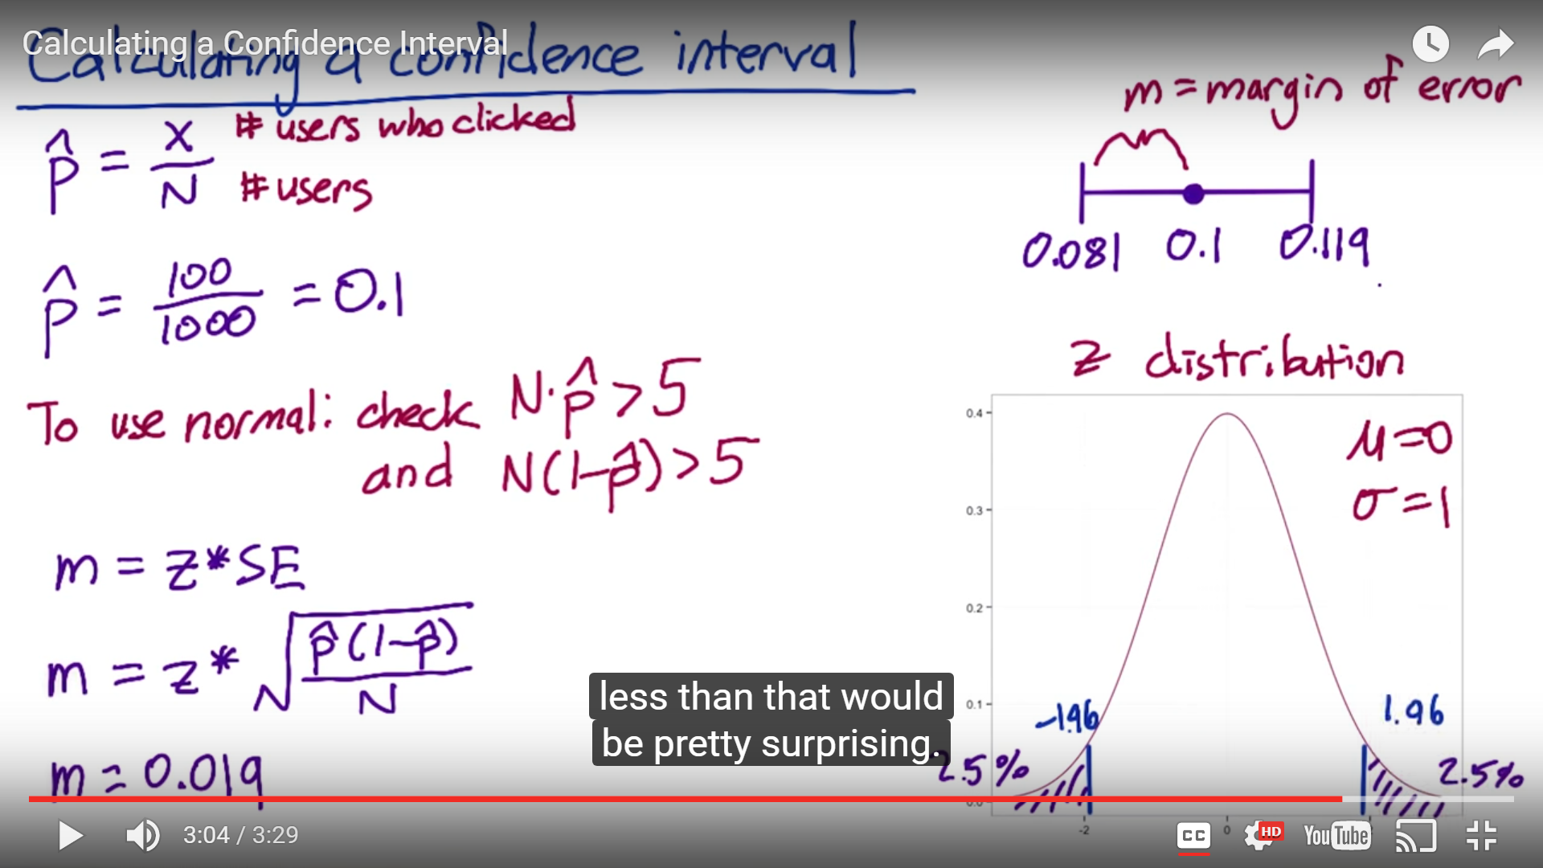

1. **Hypothesis :** Null hypothesis is that there is no difference in clickthrough probability across the 2 variations; Alternative hypothesis could be that ctp is different or higher or lower (either 1)
2. **Comparing two samples** : We will need to choose a standard error that will give us a good comparison of both



1. Next we need to decide from business perspective as to what change in the click-through probability is practically significant. Well a statistician would say, **what's substantive in addition to being statistically significant**
2. There is difference in medicinal world and online world. In medicine, you probably want the change to be 5%, 10% or 15% change to really be substantive. At Google, for example a 1 or 2% change in click-through probabilities is actually quite large
3. **Statistical significance** is about **repeatability.** So what you really want to observe is repeatability. You want to make sure when you setup your experiment that you get that guarantee that yes, these results are repeatable so it's statistically significant. But you also want to make sure that if you see a change in your experiment that you're interested in from a business standpoint, so it's practically significant, it's also statistically significant. So you want to size your experiment appropriately, such that the statistical significance bar is actually lower than the practical significance bar.
4. Given that we have control over how many page views go into our control and our experiment, we have to decide how many page views we need in order to get a statistically significant result. This is called **Statistical Power**. Now the key thing is that if we see something interesting, we want to make sure that we have enough power to conclude with high probability that the interesting result is in fact, statistically significant. Now, the key thing to keep in mind is that power has an inverse trade-off with size. The smaller the change that you want to detect, or the increased confidence that you basically want to have in the result, means that you have to run a larger experiment, so more page views in your control and your experiment.

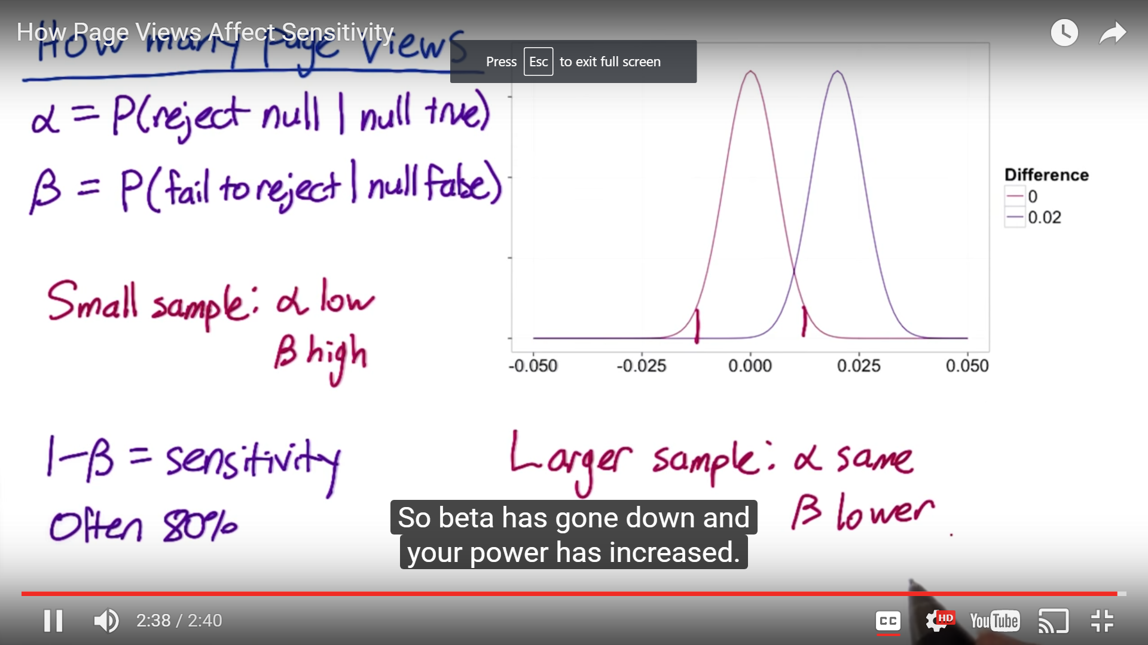

1. **Calculating number of page views: Couple of options**
   1. Built-in library
   2. Look up answer in a table
   3. Use online calculator





1. **IRB:** Institutional Review Board ensures that participants are adequately protected
2. **Metric** - First thing we want to do is decide what we are going to use the metric for before we decide how we are going to define them. There are really **2 main usecases** –
   1. **First** is the one we call invariant checking, and these are the metrics that shouldn't change across your experiment and your control. For example, if you're running an experiment and control, one major term of comparison is, are the populations the same? (you can check these by number of users, distribution is same or not, comparable number of users across countries, languages etc.)
   2. **Second usecase** is going to be evaluation - For this first you have what you think of as high level business metrics, so that might be how much revenue you make, what your market share is, how many users you have. And then you're going to want more detailed metrics that focus on, say the user experience with actually using your product, how long did they stay on page etc..
      1. **Example** Let's say users aren't finisihing their class on audacity. We don't know why but we want to dig in to the user experience for that class. Maybe the videos are taking too long to load and maybe we should look at latency, maybe some of the quizzes are particularly difficult, and the students are having trouble with that. So what we want is a set of techniques to help us really dig into that user experience. There are bunch of techniques, one of them is about user experience research which we can use in order to brainstorm metrics. And sometimes business metric might not work out in the context of any experiment. So for you may not have the information you need, or the time that you are running the experiment may be too short to measure what you want. If we think about our online courses, maybe what we're really interested in is whether students get more jobs after taking the class, or something more nebulous like did they have improved skills. Now the problem with the jobs one is we just don't have complete information. We will never really know if the students got the job because of the online class except maybe after a very long period of time. Also, we don't have time because we are running the experiment now. Then there are other category of things that are more nebulous like improved skills. how do we really measure that in an experiment?
3. If you have multiple metric, one thing what you can create a composite metric. This can be something called an **objective function or an OEC (Overall evaluation criterion)** if you running a whole bunch of AB tests, it is best to come up with a metric which will be relevant across the suites of test you are running as oppose to coming up with a specific metric just for a particular test

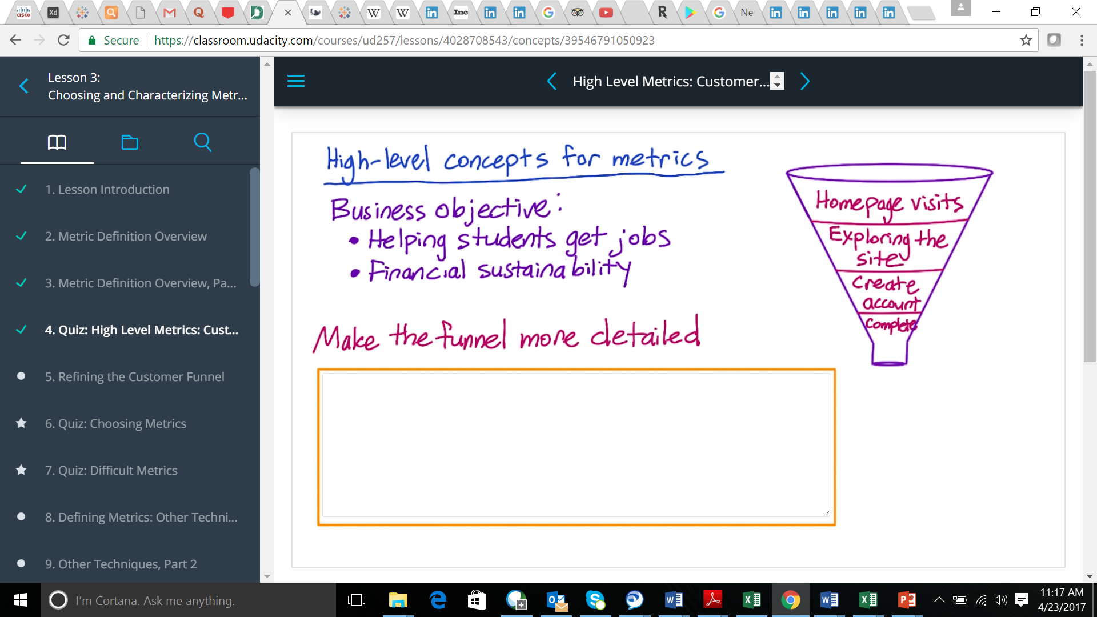

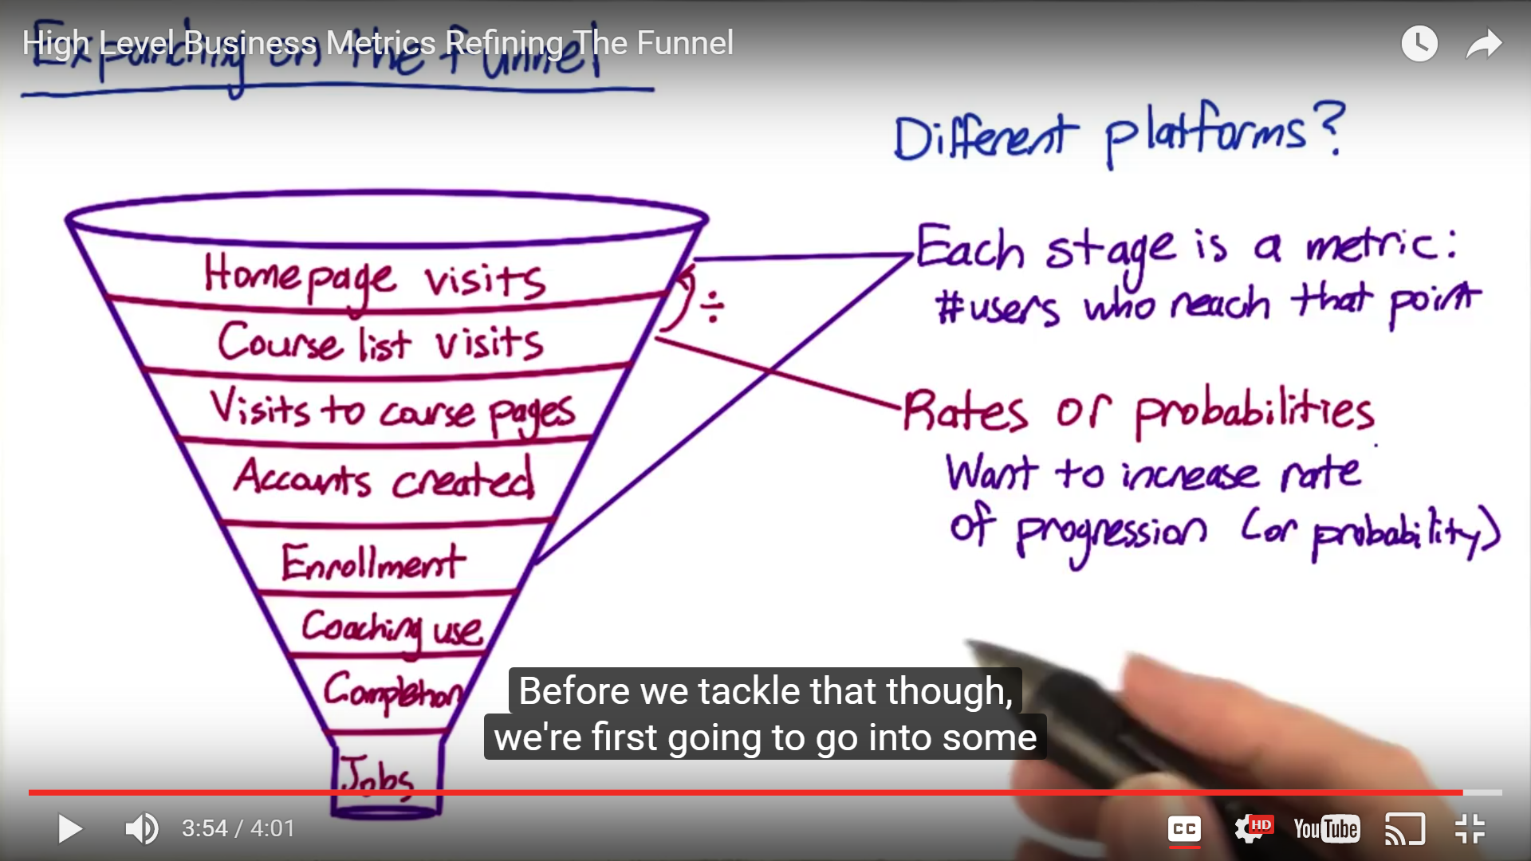

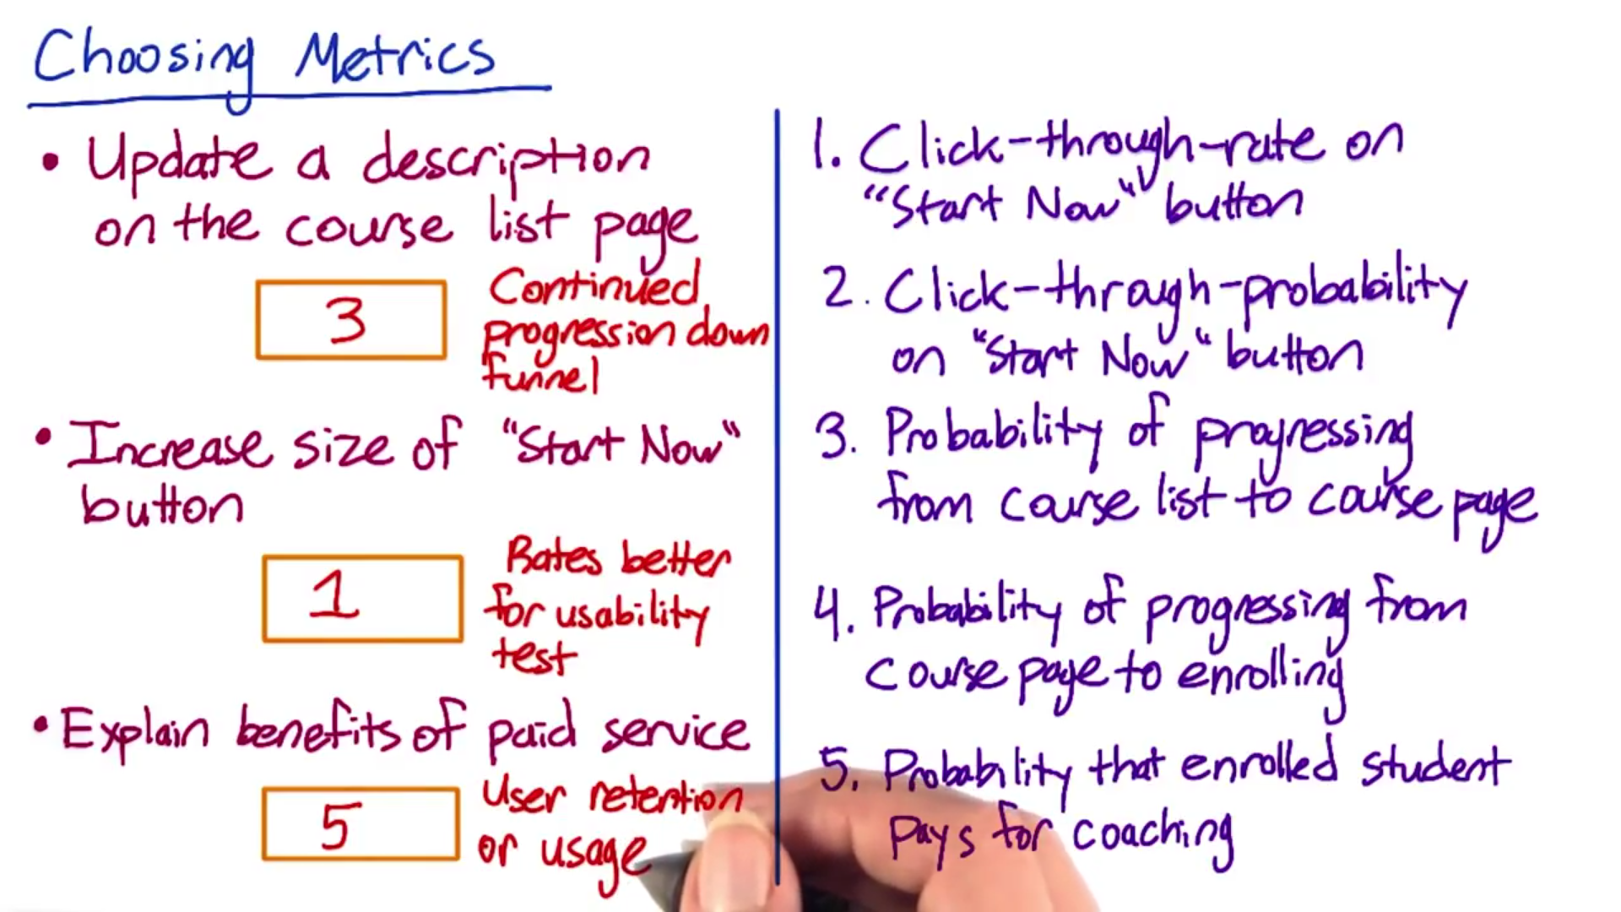

1. There are lot of **different techniques** to come up with proxy for a metric whenever you have difficulty in defining/measuring a metric - like **surveys, retrospective analysis, focus groups**. These techniques can be used to brainstorm for new metrics, as well as validating possible metrics
2. **External data sources** –
   1. Companies like **comScore, Nielsen** they collect info regarding market share, visitor data to your website
   2. 2nd type of companies are those that run surveys of users - like **Pew or Forrester** - they may ask users how many devices do you have? How much time do you spend on them in a given day?
   3. Third category is what I would call **Academic research** - these are papers that actually try to establish metrics, they may run correlation studies

You can use these sources in multiple ways.

1. First of all, they're great for brainstorming (new metric ideas)
2. Second is good for validating metrics
3. 3rd is they can help you develop validation techniques
4. **Internal data sources** - There are 2 uses of this:
   1. First one wherein you use all of existing data to track the health of your business.
   2. Now the (2nd) other class of methods is when you want to gather new data. The main techniques here are going to be user experience research, surveys & focus groups
5. So let's talk about what you can do with your own logging data or data capture, from your site. First what you can do is called **retrospective analysis or observational analysis**.
   1. You can understand how have your customers behaved historically when intervened with different marketing campaigns, changes to the website. The problem with this type of analysis is that they help you do the correlation not necessarily causation. (Interesting thing is that you can run A/B tests to understand which metrics move and then use that to understand which metrics you want to use for experiments)



1. For any metric that you might come up with during UER (to investigate low completion), you might want to validate that with retrospective analysis to see how that metric varied over time or run some experiments to evaluate how that metric changes. How many students got the job because of the online course? You might want to use surveys as that's how you will be able to collect data. Keep in mind though you can't compare the results from survey metric to what you get from any other measurements because populations might not be comparable (survey vs internal data customers), you may be reaching to the biased population for the survey relative to the population of overall class

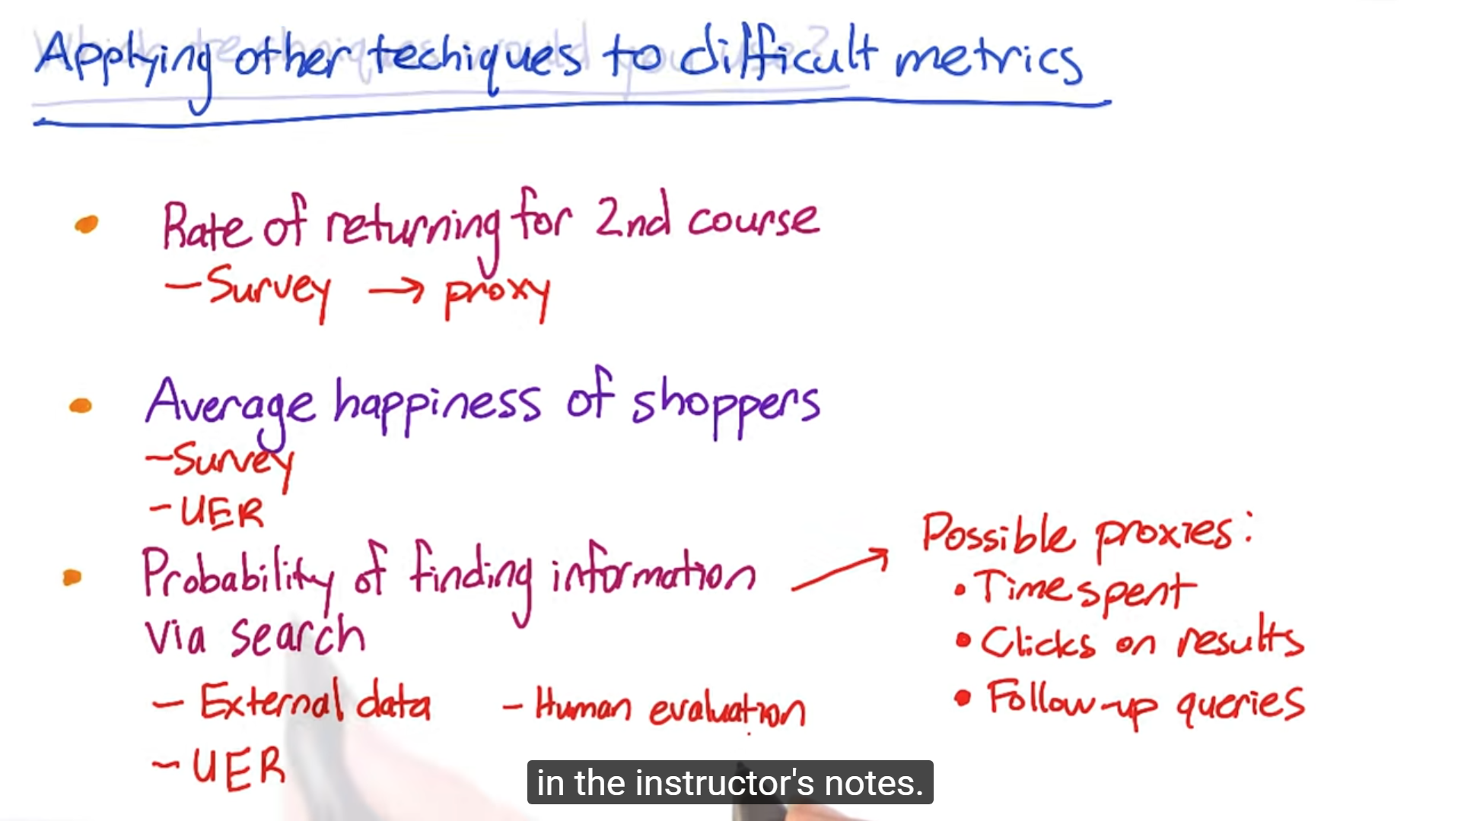

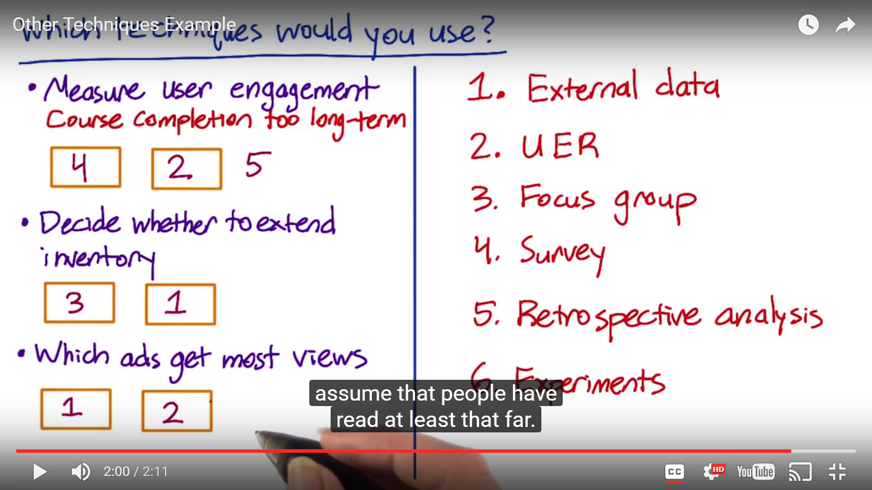

1. Javascript pings which send a 204 request, are one of the most common ways of actually capturing clicks. Now when you look at different browers (IE, mozilla, chrome), you get very different click-through rate because javascript has different failure rates on different platforms. In reality the CTR is not different, it's just that the technology that you used to compute it is different, in these cases you need to work with your engineering team to understand these nuances.

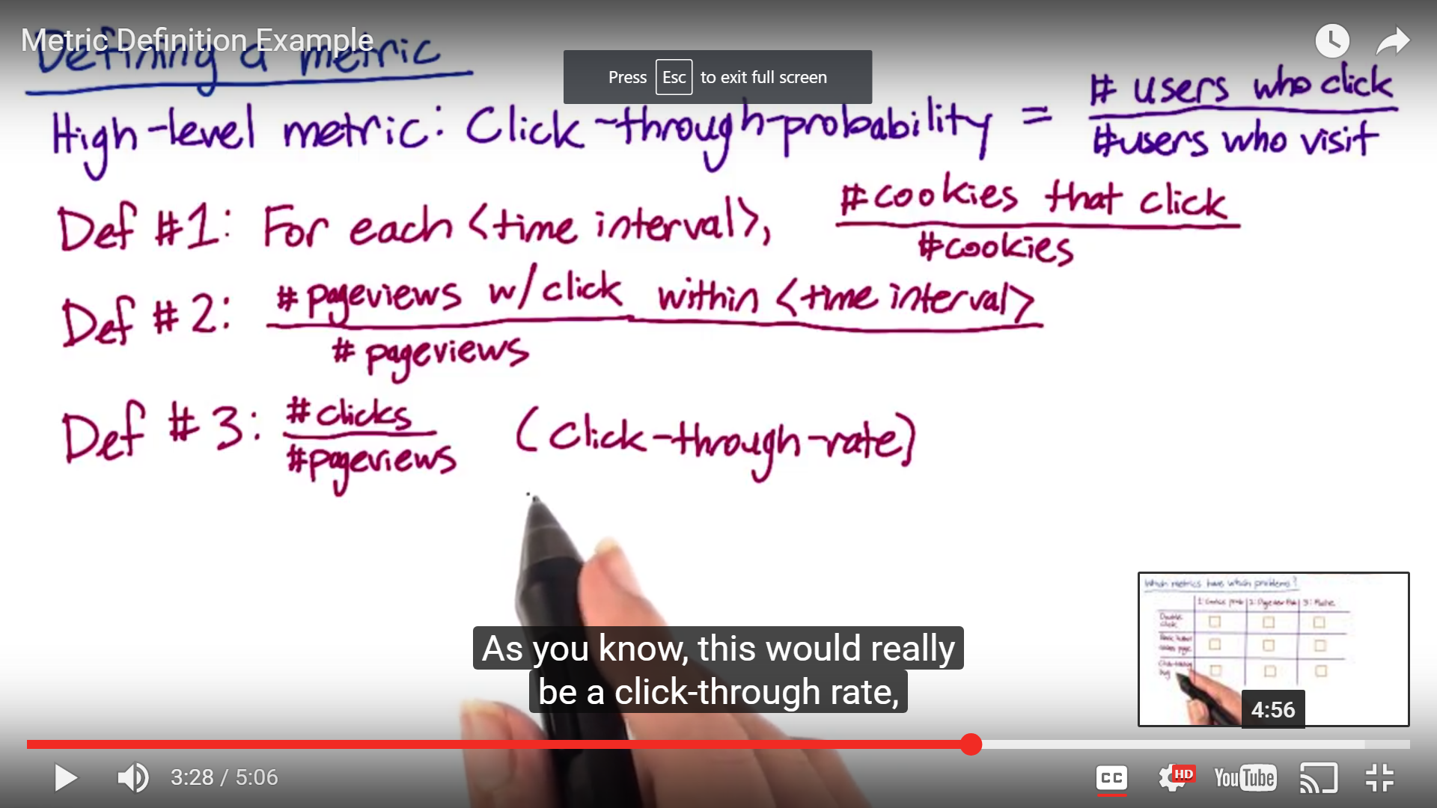

1. You would want to slice/dice your data in a manner where in you are able to look at d/d, w/w, q/q trend or even slicing the data by different dimensions will tell you because usually when you have bots/spams they come from a single IP, in a short period of time so you can easily filter that out. You would want to filter out these traffic as they are just spam..... With this kind of analysis, you also build intuition about your data





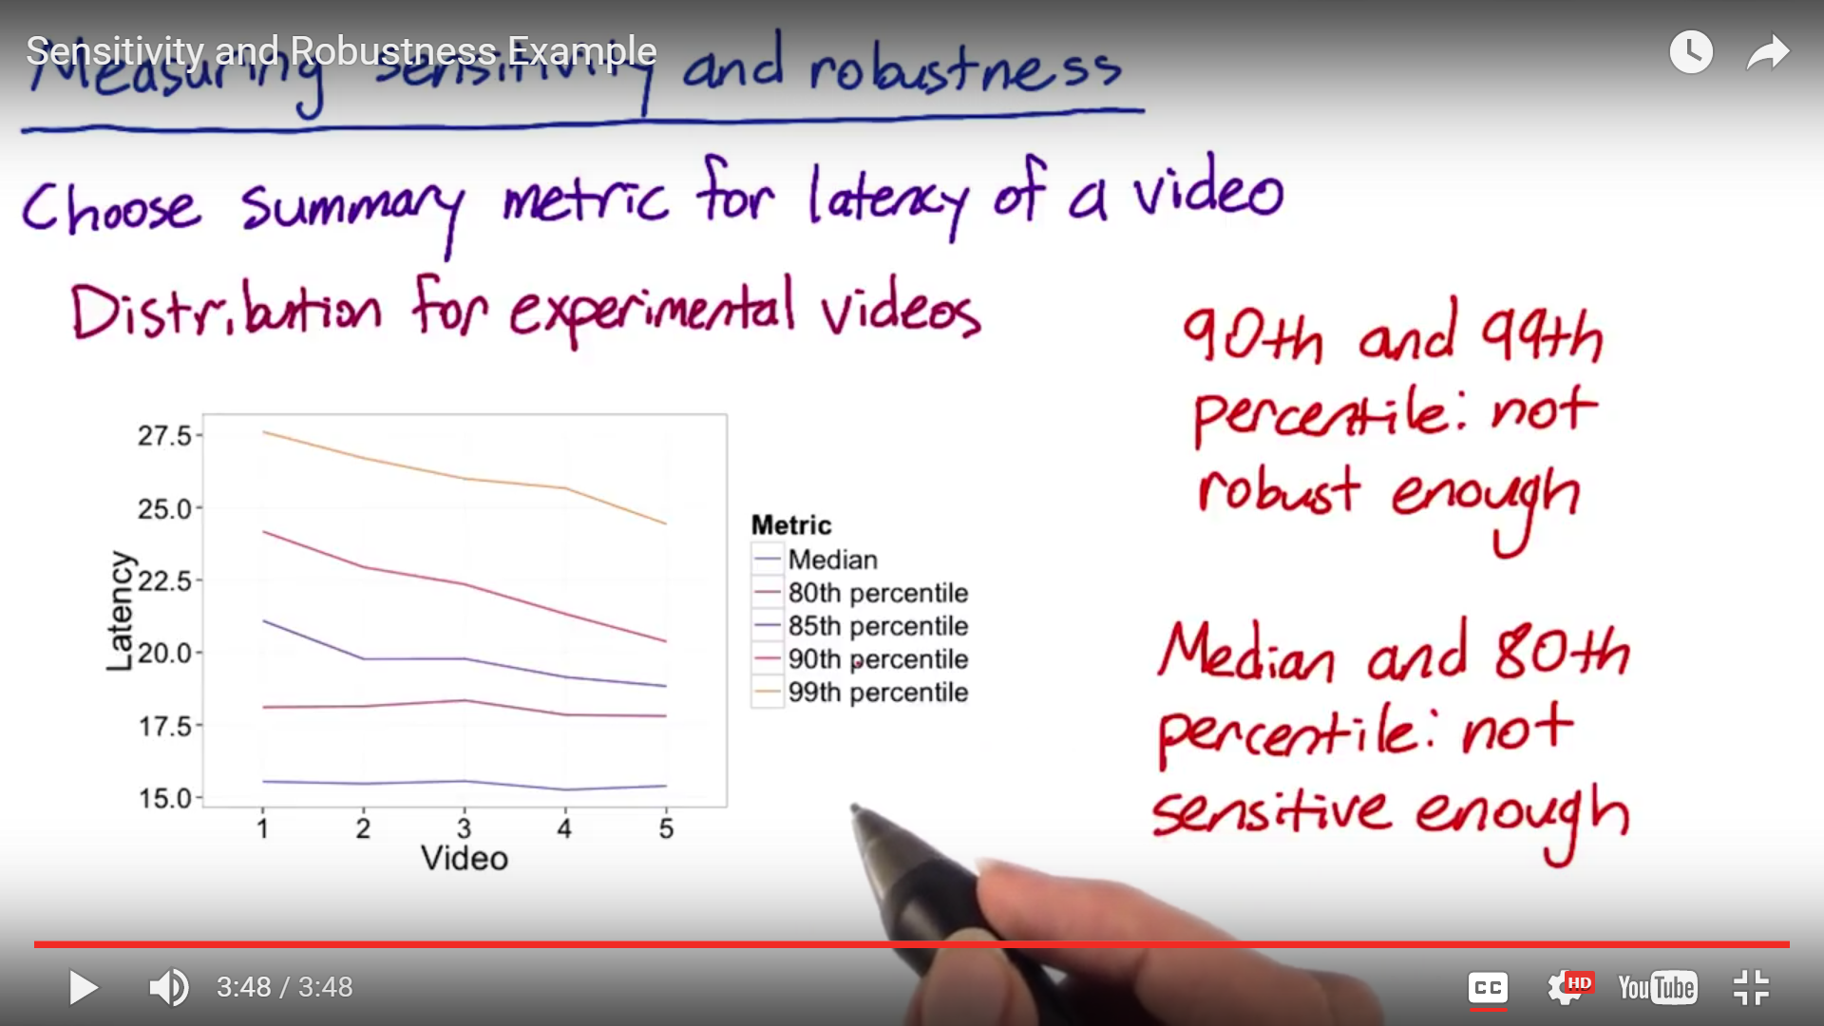

1. Relative difference usually makes sense as % change would also accommodate for any changes in the business (June vs dec example). Main thing to consider is variability because Ratios such as relative difference is not always well behaved as absolute differences so if you are new start off with absolute difference.



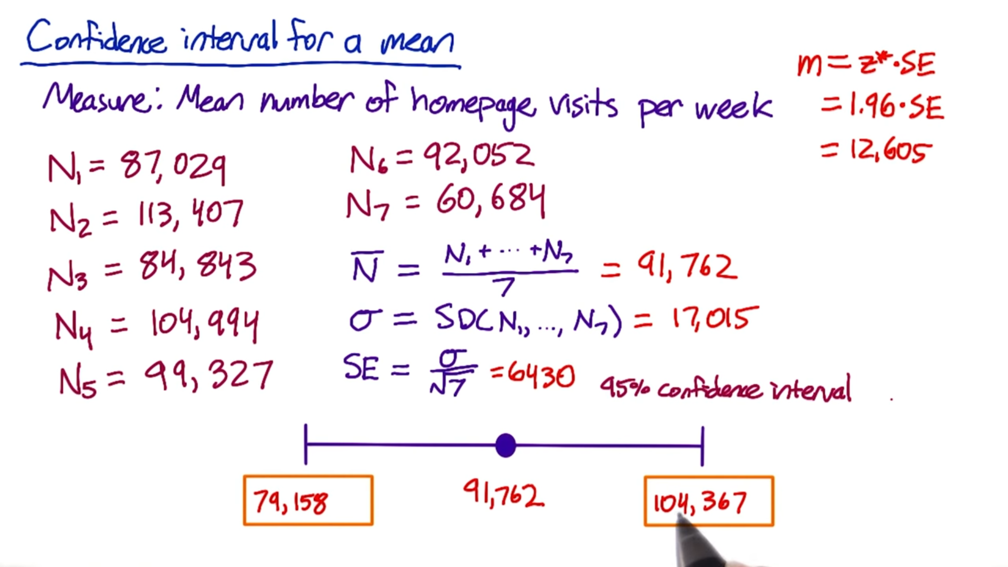

1. **Standard Error = square root of the variance**
2. **Non-parametric methods (Sign test):** With this you have a way to analyze the data without making an assumption about what the distribution is. These methods can be noisier and computationally intensive, but they can also be very useful. (esp. needed when you are dealing with complex metric like ratios,median/percentile)
   1. You can compute non-parametric confidence interval. Downside is you don't know the size of effect.
   2. For more complex metric, you need to compute the variance empirically instead of computing it analytically
3. You can use A versus A experiments, to actually test for the sensitivity and robustness of metrics. If you see too much variability in your metric when doing A versus A experiment then that metric is too sensitive to be useful in evaluating a real experiment. You can also use this method to validate the metric which you have computed empirically.
4. Generally at Google, we started with 5 A vs A test, then moved on to 10 and now we have 100's of variation of A vs. A test. Another option would be to Run very big A vs A experiments, and then there's a **method in statistics** called the **bootstrap**, where what you do is you take that big sample, and you randomly divvy it up into a bunch of small samples and you do the comparison within those random subsets. Now if your bootstrap approach matches that with the analytical approach then you don't have to worry about things, however if they don't match you might be better off to run multiple A vs A test.

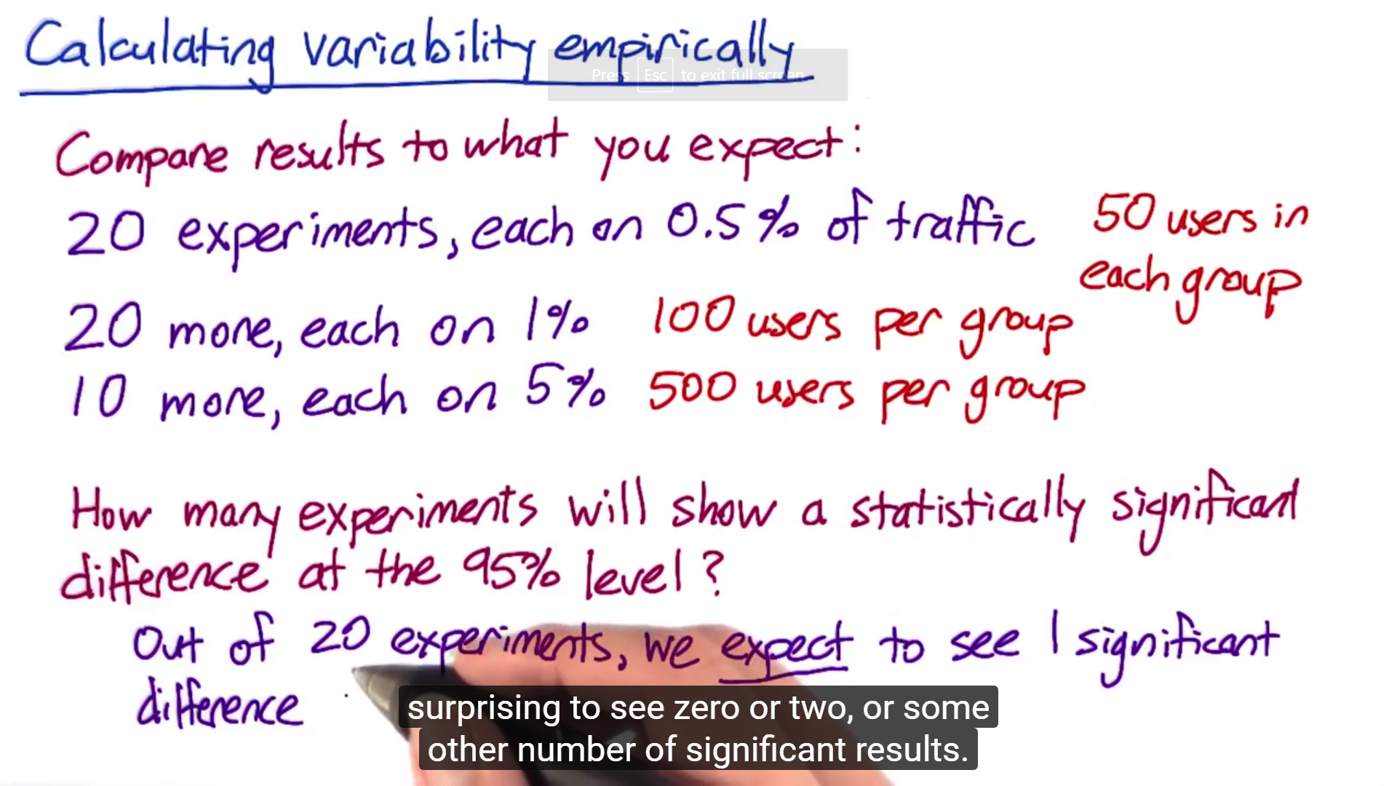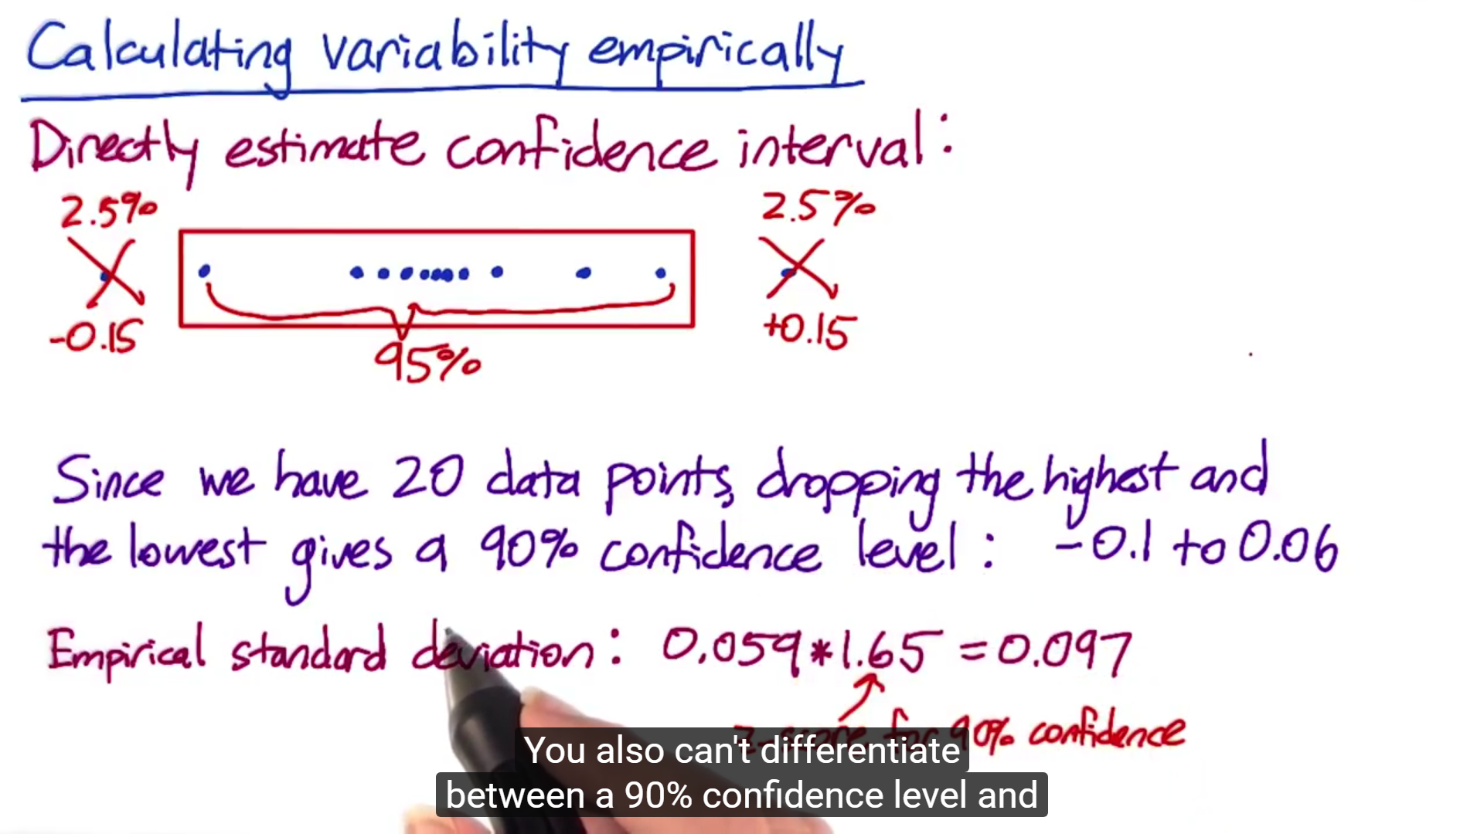

1. For **Bootstrapping** - When collecting a random sample for bootstrapping, it's important to sample with replacement - meaning it's possible to choose the same event twice within a group.

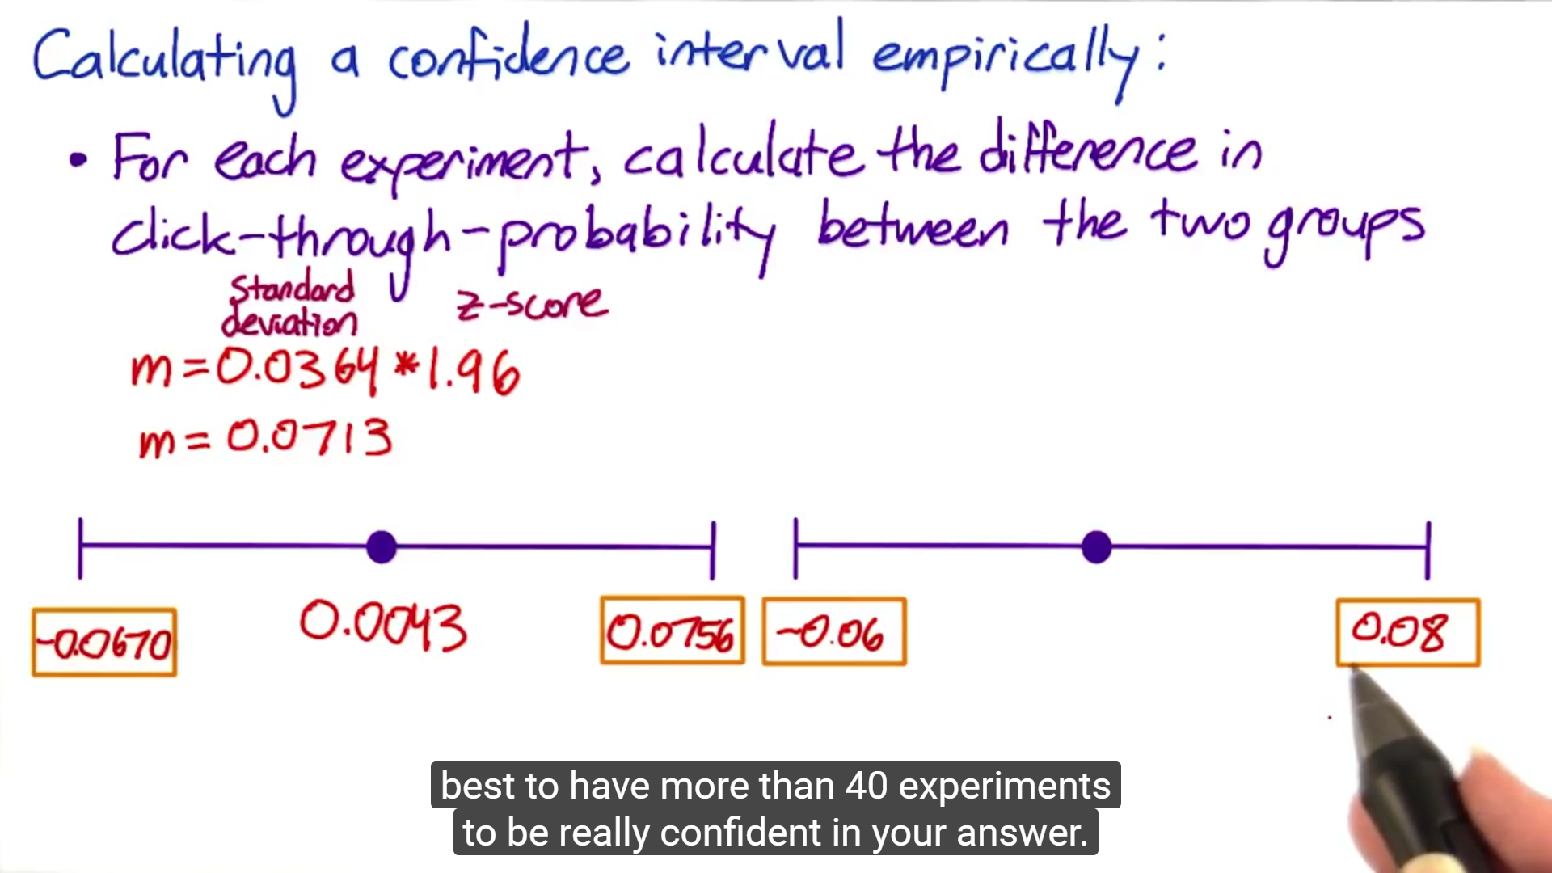

1. **Variability Summary**:
   1. Different metric have different variability
   2. In fact, the variability maybe so high for a metric, that's actually not practical to use in your experiment even if the metric makes a lot of business or product sense.
   3. In order to compute variability, we need to understand the distribution of the underlying data.
   4. We looked at Analytical techniques as well as Empirical techniques to be able to compute the variability
      1. *At Google, we spend a lot of time coming up metric and esp. validating the metric. Latency could be a good example wherein median/metric might not work well because the distribution is very lumpy as you have customers with different internet speeds so if you track median that might not move et all so that's where you might be interested in looking at percentile values*
   5. Variability (analytically or empirically) - It's usually good to start out with some kind of analytical characterization of your variability
2. Now whether you are doing an **event based diversion**, **a cookie based**, or **a user ID**, these are all what we call our unit of diversion. **Unit of diversion** is how we define what an individual subject is in the experiment

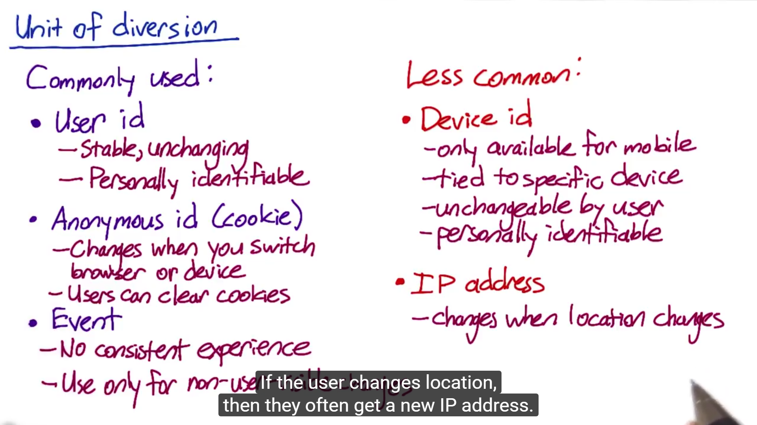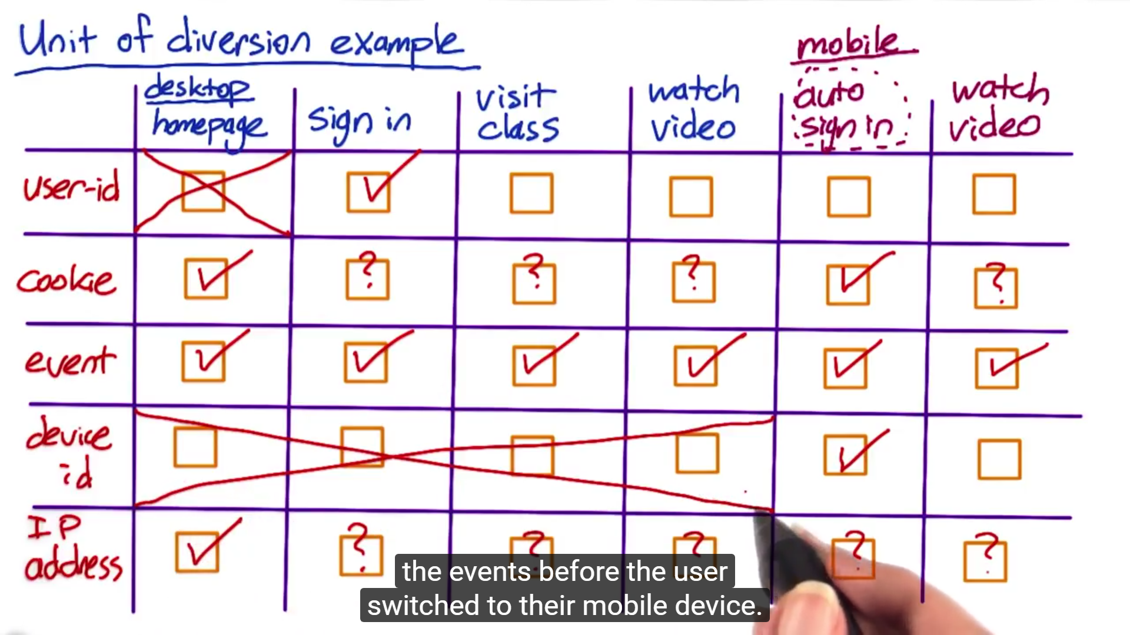

1. For user visible changes, we would definitely use a cookie or a user ID so that the change is consistent across and user sees the same variation. Now there are lot of changes that are not visible to users for example latency changes, ranking changes, backend infrastructure changes where you can use event based diversion. However it also depends upon what you are trying to measure. for example if you want to check how does changing the latency changes the use of the website... although it is not user visible change in this case you would still want to use either user id or cookie because you want to see how does the change impact the user behavior over time. Generally speaking, I don’t like IP based diversion because you don't get the same set of consistency (like user or cookie) nor do you get the randomization (like in event based diversion) but there are instances wherein you can only use IP based diversion as your only choice. For instance let's say for example your testing out an infrastructure change when you're testing out one hosting provider versus a different hosting provider to understand the impact of latency. In this situation, IP based diversion may really be our only choice. Challenge with IP based diversion is doing the actual analysis because what may happen with IP based diversion is that you may not get a clean comparison between your experiment and your control. So when you do IP based diversion, you do a lot of post analysis to find those good comparisons between your experiment and control.

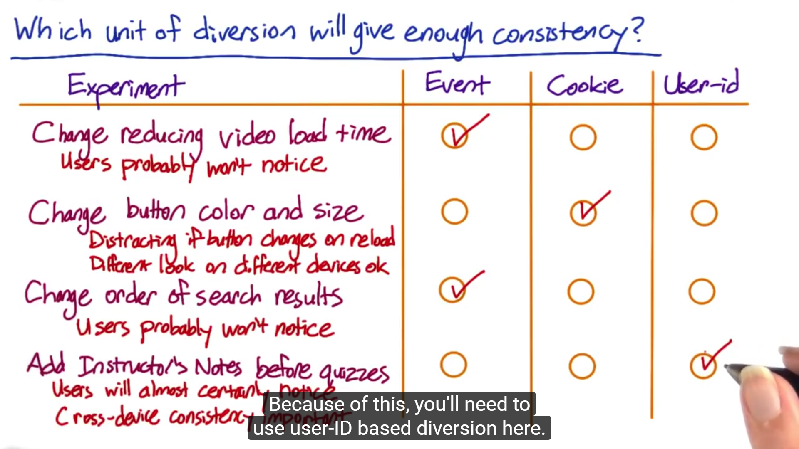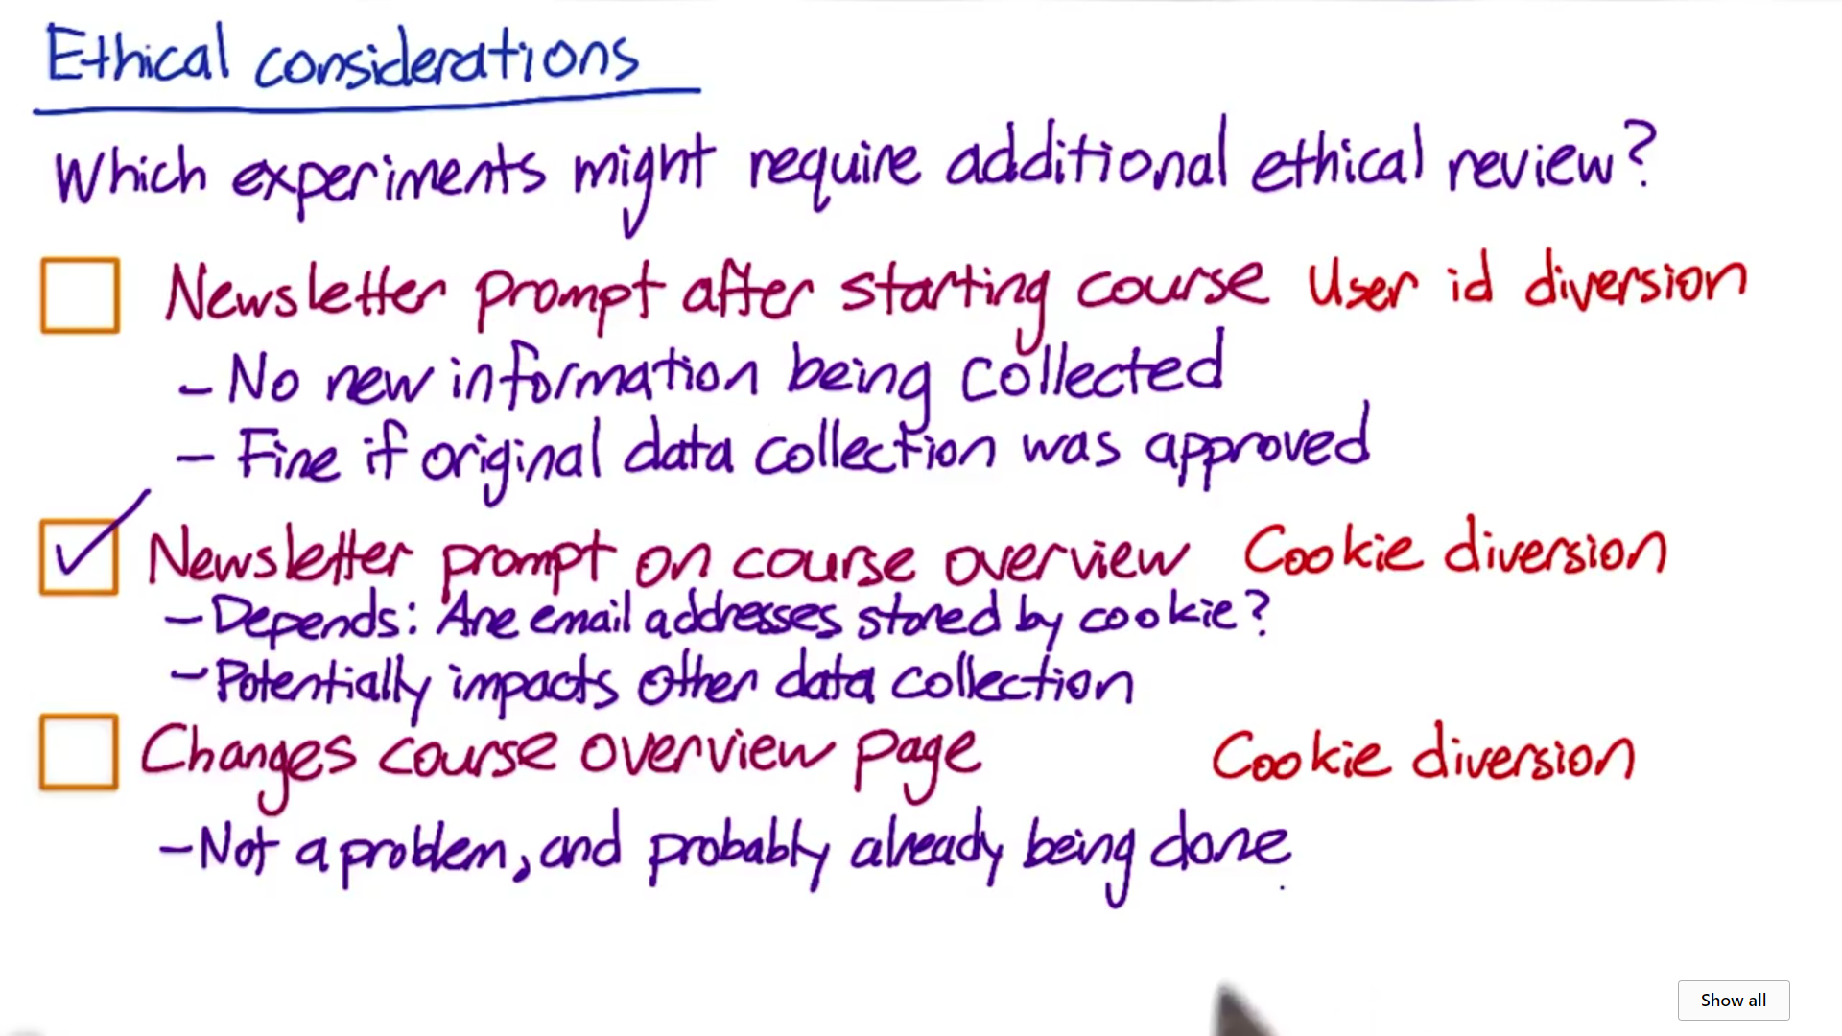

1. **3 Things** to consider when designing an experiment:
   1. **Consistency of users**
   2. **Ethical considerations**
   3. **Variability**
      1. Sometimes empirically computed variability is much higher than analytically computed variability so you need to compute it empirically as well. Now this happens when **unit of analysis is different from unit of diversion**.
         1. Unit of analysis is basically whatever the denominator of your metric is. For example when you are looking at Click Through Rate then you have clicks divide by page views then page view would be your unit of analysis now when your unit of diversion is also page views as would be in case of event based diversion then analytically computed variability is likely to be very close to empirically computed variability if however your unit of diversion is cookie/user id then the variability of same metric (CTR) would be much higher (maybe by a factor of 4 or 5 or even more) and in these cases you really want to move to empirically computed variability given your unit of diversion. So what happens is that when you are computing your variability through analytical method then you are making a fundamental assumption about the distribution of data but you are not just making assumption about the distribution of your data, you are also making assumption about what's considered to be independent. You are basically doing these random draws and whether they are independent or not, when you are doing event based diversion, every single event is a different random draw and so your independence assumption is actually valid now when you are doing cookie/user id based diversion then your independence assumption is no longer valid because you are diverting groups of events. And so they're actually correlated together and that will increase your variability greatly.

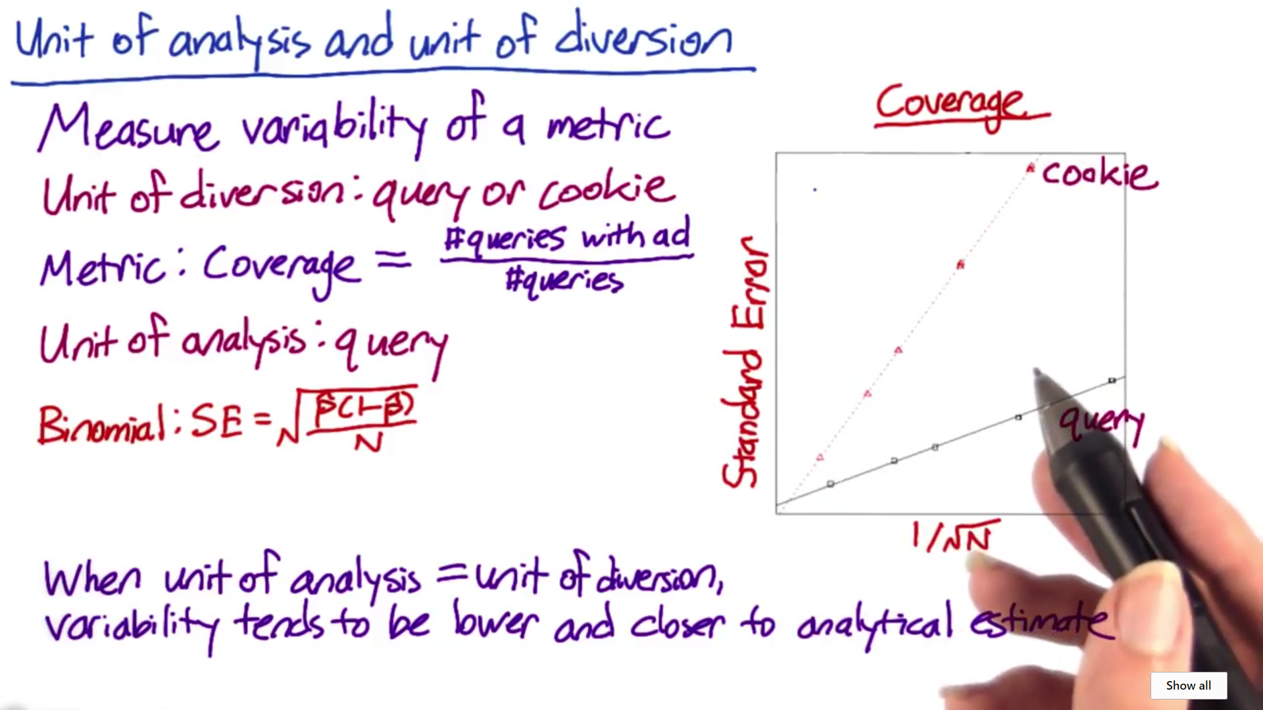

1. **In general, you would want your unit of diversion to be as big as unit of analysis**

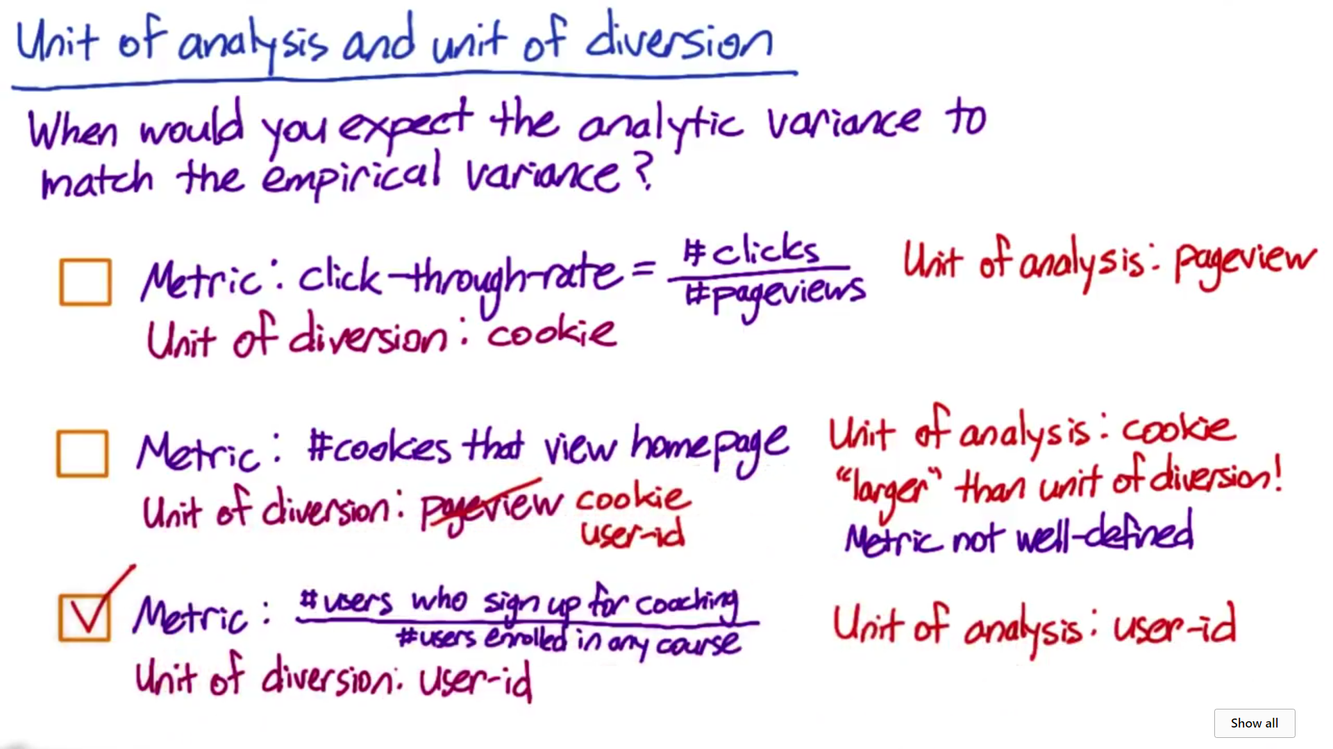

1. In Intra user based experience, it means that you expose the same user to this feature being on and of overtime, and you actually analyze how they behave in different time windows (be very careful that you choose a comparable time window). There is another type which is called interleaved experiment where in you expose both the variants to the same user and study their behavior.

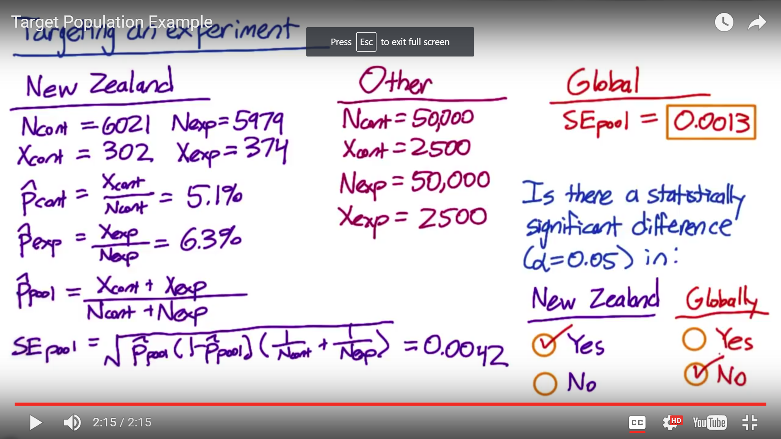



1. Since the margin of error is wider than the estimated difference, the confidence interval will include 0 which means that the difference is not significant!
2. When to use **cohort vs population** - Cohorts are harder to analyze and they're going to take more data because you'll lose users. So typically, you only want to use them when you are looking for user stability so say, you have a learning effect or you want to measure something like increased usage of the site or increased usage of a mobile device. Those are cases where you really want to see if your change had a real effect on their behavior relative to their history.

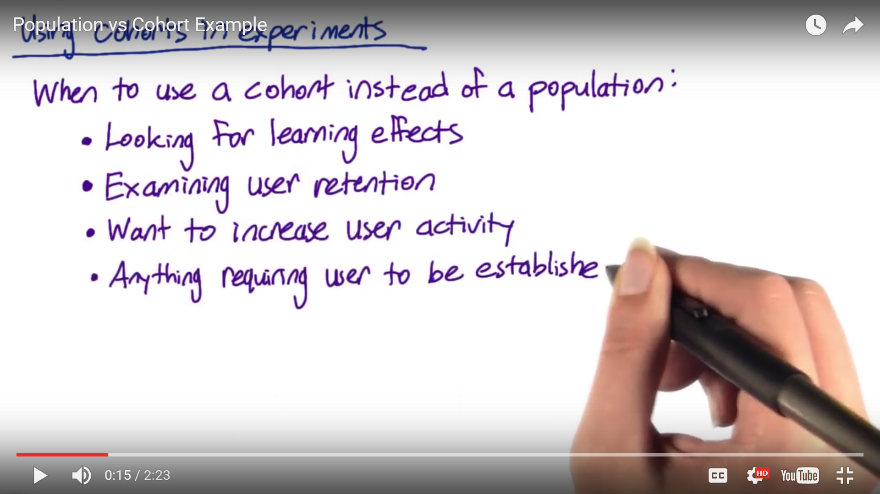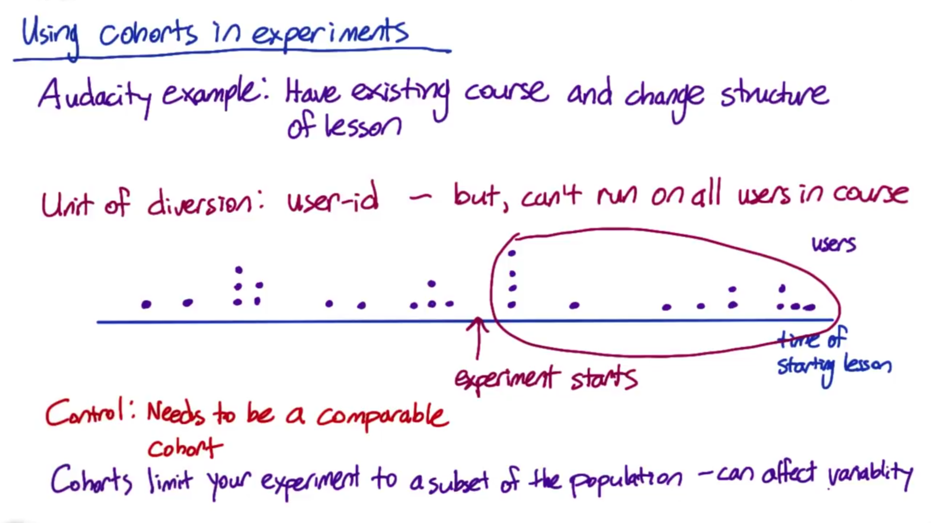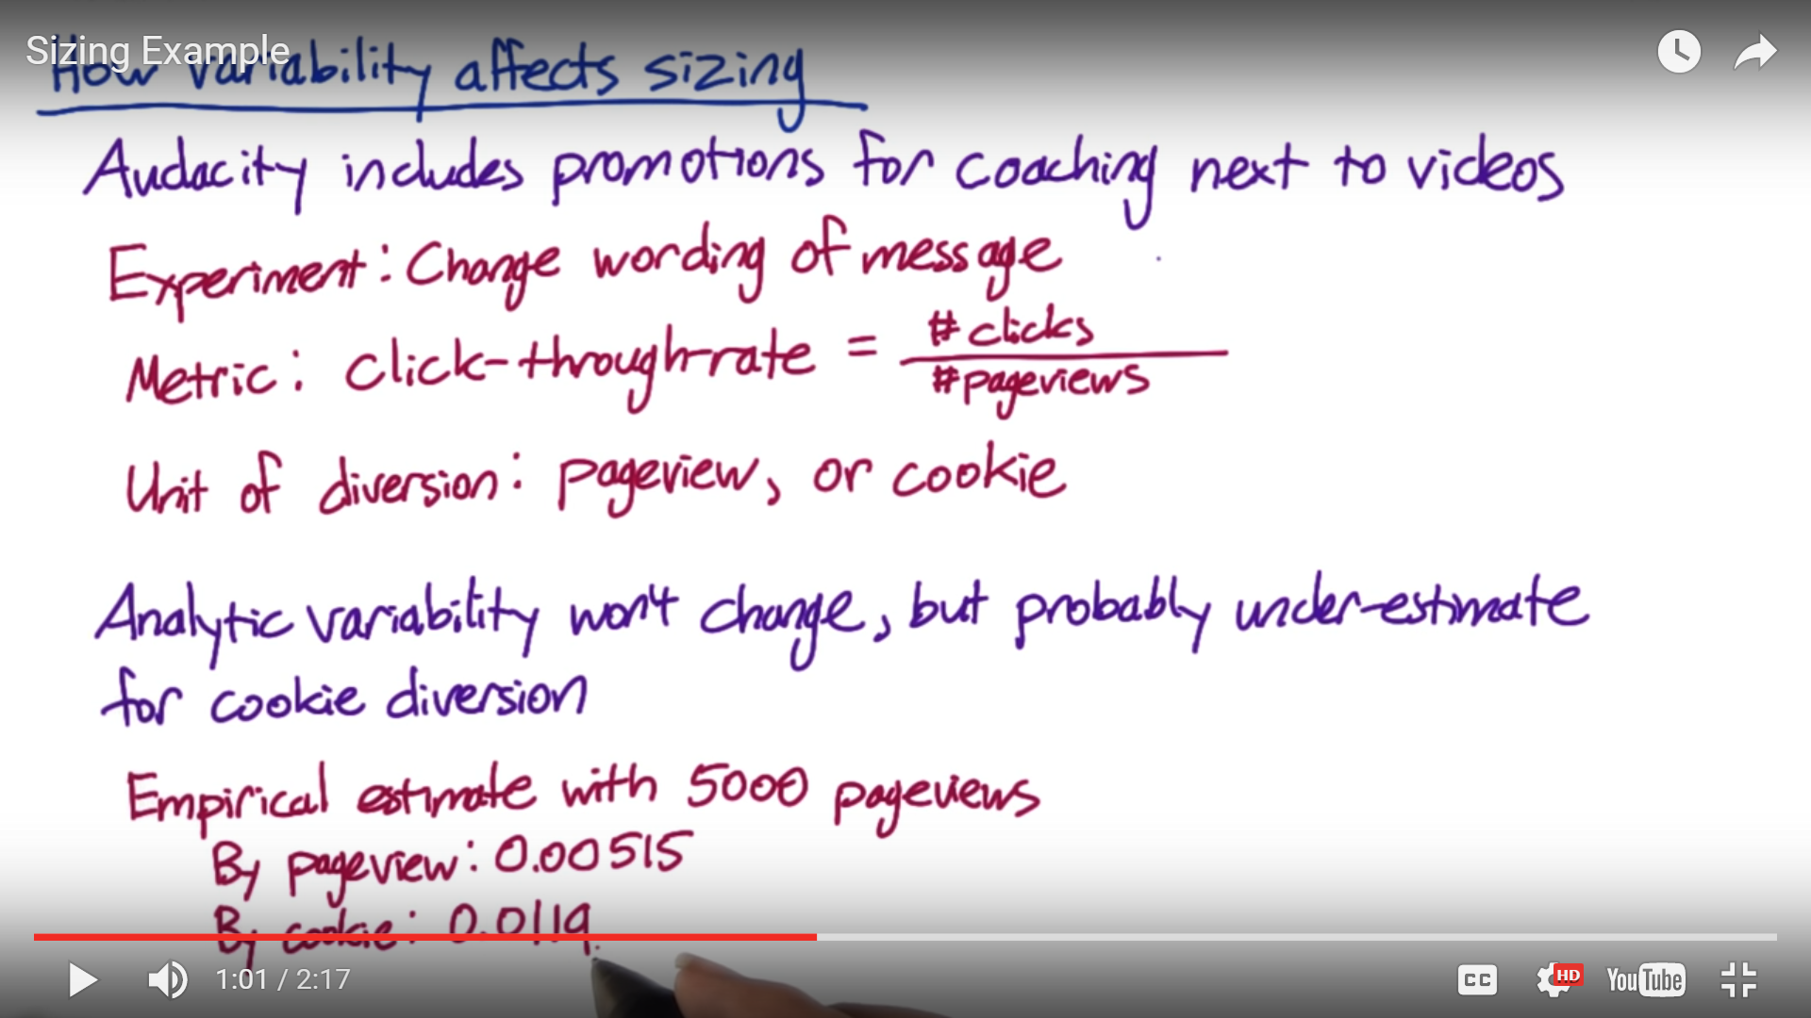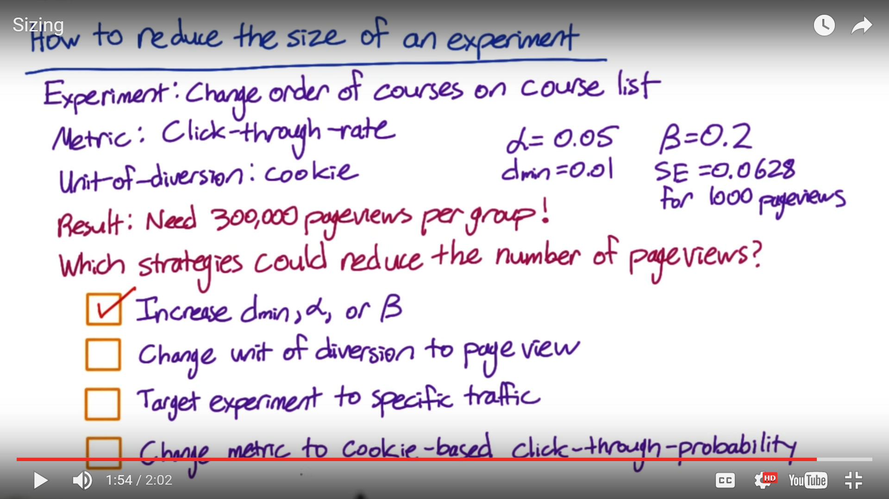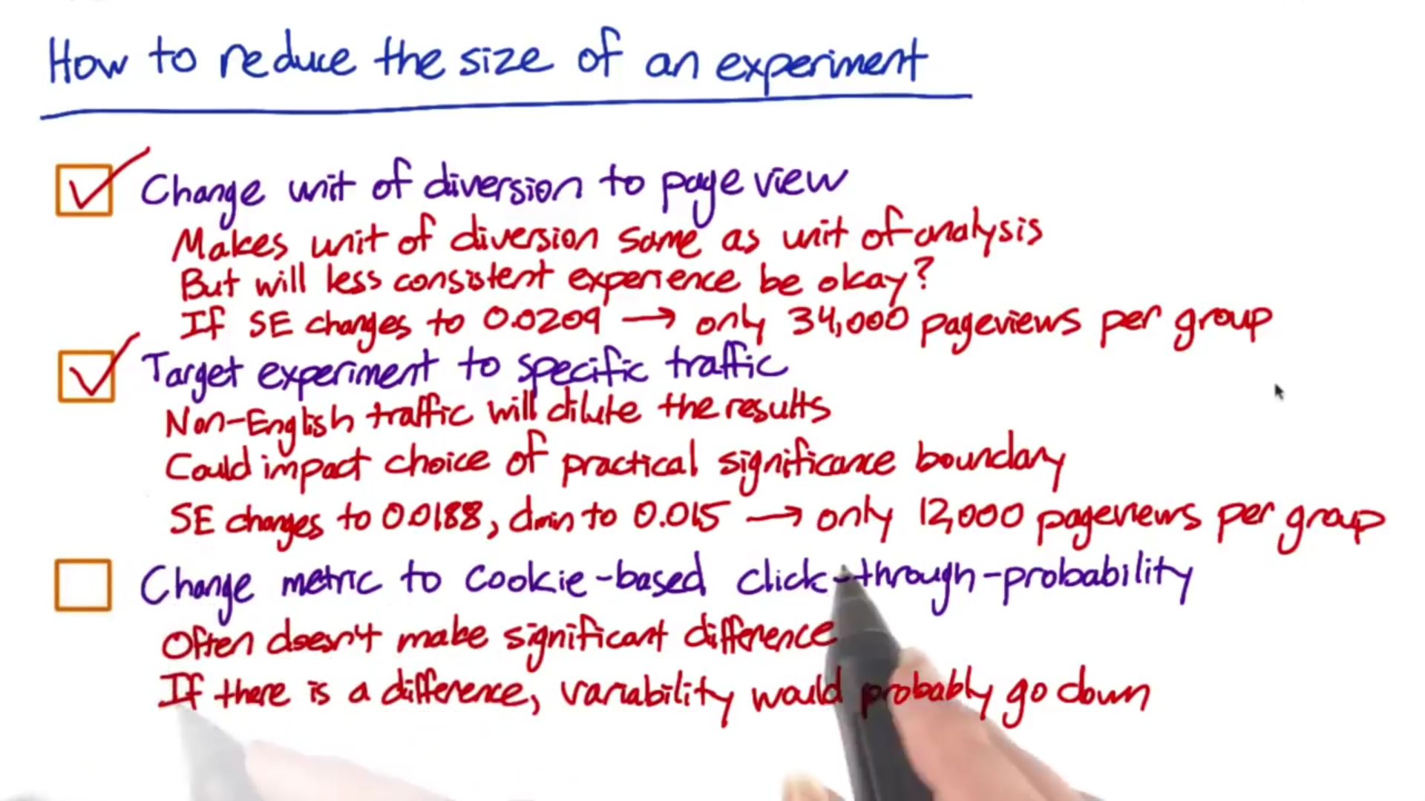

1. Well we have to translate our ideal size into a set of practical decisions.
   1. First of all, What is the duration of the experiment that I want to run?
   2. Secondly, When is the right time to run (Back to School, Christmas others)?
   3. Third, you have to think about what fraction of your traffic you're going to send through the experiment. Those are all interrelated as they get you to the ideal size but you need to think about them a little bit separately.
2. Example - let's say unit of diversion is cookie so what we are asking is at any given day what proportion or percentage of the cookies are you sending to your experiment and your control? Now let's say we have done our sizing and we need 1 million cookies in our experiment and our control combined. Now if you get 100,000 cookies visiting your site on any given day. That means that if you want to run 50% of your traffic through experiment and 50% through the control, you need to run your experiment control for ten days. Now another choice is to run your experiment at 25% each, say, it's because you want to run another test, then you'd have to run your experiment for 20 days as opposed to 10. And that's how duration of your experiment is related to the proportion of traffic that you're sending through your experiment. You wouldn't want to run your experiments on all your traffic because of couple of reasons: Safety, you don't really know how the new UI change is going to operate on different browsers, you would want to test it first or you don't know how the users are going to react. The other reason would be press, let's say you have a new feature you are not sure if you want to keep it. You don't really want a lot of people to see that feature esp. if you're not sure if you are going to implement that change in the website as you don't want people blogging about it.......+ you would want to run on smaller (not all) proportion of traffic so that you capture their behaviour over different days in a week, weekend , timing because consumers behave differently at different time and you wouldn't want to make a decision based on a single day (let's say holiday by directing the experiment to all your traffic). Lot of times you are running different variations of change so you would want to run on smaller traffic so that it's easier to do the comparison if the experiment is conducted at the same time.

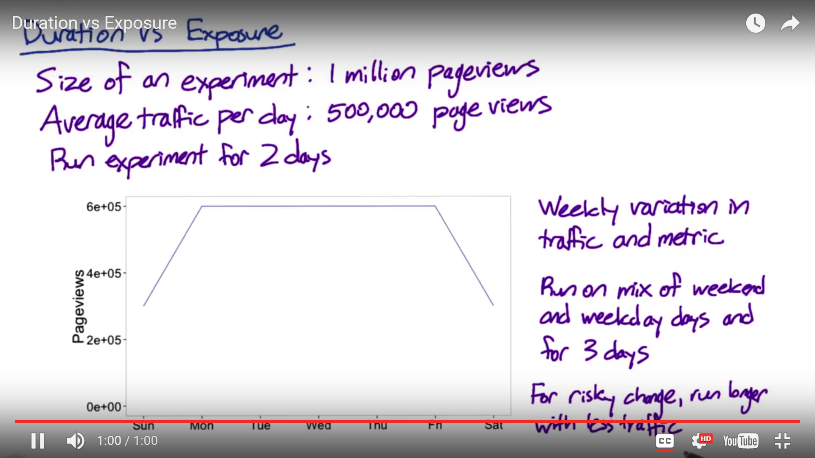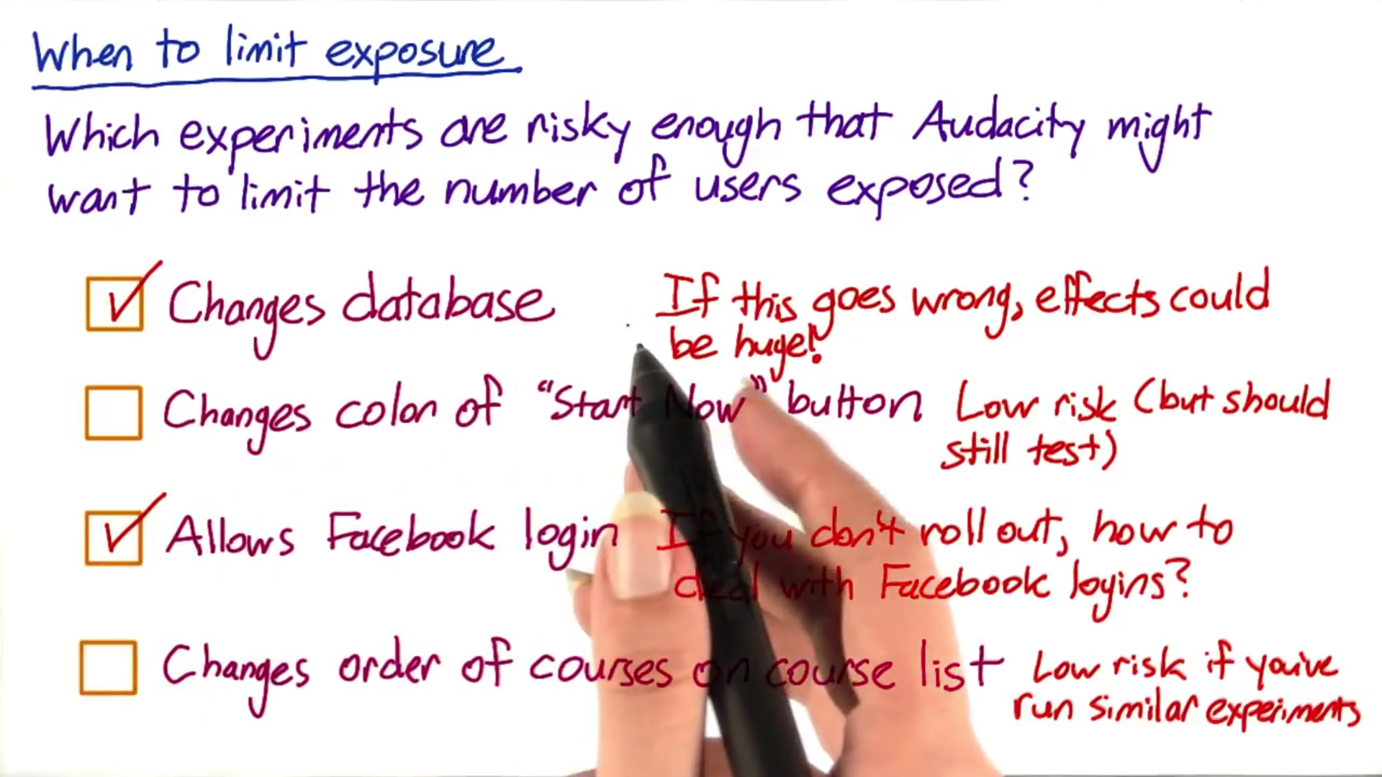

1. **Learning effect** - Whether the user is adapting to a change or not? 2 different types of learning effect:
   1. First type is **Change aversion**, where when users first see a change they're like, what is this? I don't like anything.
   2. 2nd type is a **Novelty effect** which is the exact opposite... "Oh, this is a new thing.... what's going on... let me try everything around.."

Issue with learning effect is that you would **need time** to assess the impact as users take time to adapt to a change. But if you do have time then there are few things to keep in mind:

1. First is choosing the **unit of diversion correctly**, if you want to measure user learning, you need a stateful unit of diversion like a cookie or user ID.
2. The second issue that we want to take into account is that because a lot of the learning is based on not just a slight time but how often they see the change so we call that a dosage. Then you probably want to be using a cohort as opposed to just a population. And so you would choose a cohort in both the experiment and the control based on either how long they've been exposed to the change or how many times they've seen it.
3. Now the last issue is a question about both the risk and duration. Now from duration perspective, you are going to need some amount of time to basically see what's going to be happening. From risk perspective, because you don't know how the users are going to react you want to study the learning effect now that could be risky... both of these would mean that you would want to run your experiment on a small proportion of traffic over longer time frame...... At Google we do pre-period and post period tests (which is similar to A vs A test) and if you see your user behaviour in pre period test to be different between 2 groups then you know it's because of system variation, user variation or something else ...... post period means after I have run my A/B test, I would run another test (A vs A) then we can say that if there are difference in behavior of my experiment group and control group then you can say that the behavior change is due to the learning effect (based on your experiment) so you can attribute the change behaviour to your experiment.
4. **Chapter 5**
5. **Invariant metric** - There are 2 types of sanity checks you can do with invariant metrics:
   1. First one is the **population sizing metrics**, based on your unit of diversion. What you are checking here is that your control population and your experiment populations are actually comparable.
   2. The other(2nd) check are those invariant metrics which shouldn't change when you run your experiment. So you would want to test that they didn't change. Once we do these 2 sanity checks, after that only we should be analyzing the results of the experiment.

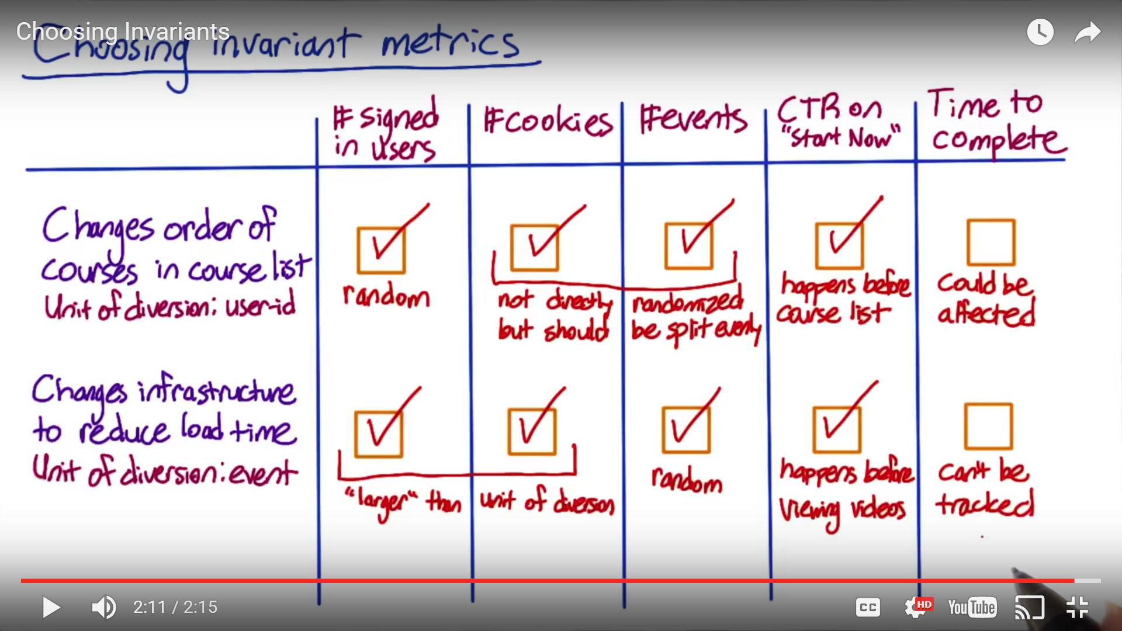

Number of signed in users & number of cookies are larger than number of events in the sense that one user or one cookie can correspond to multiple events.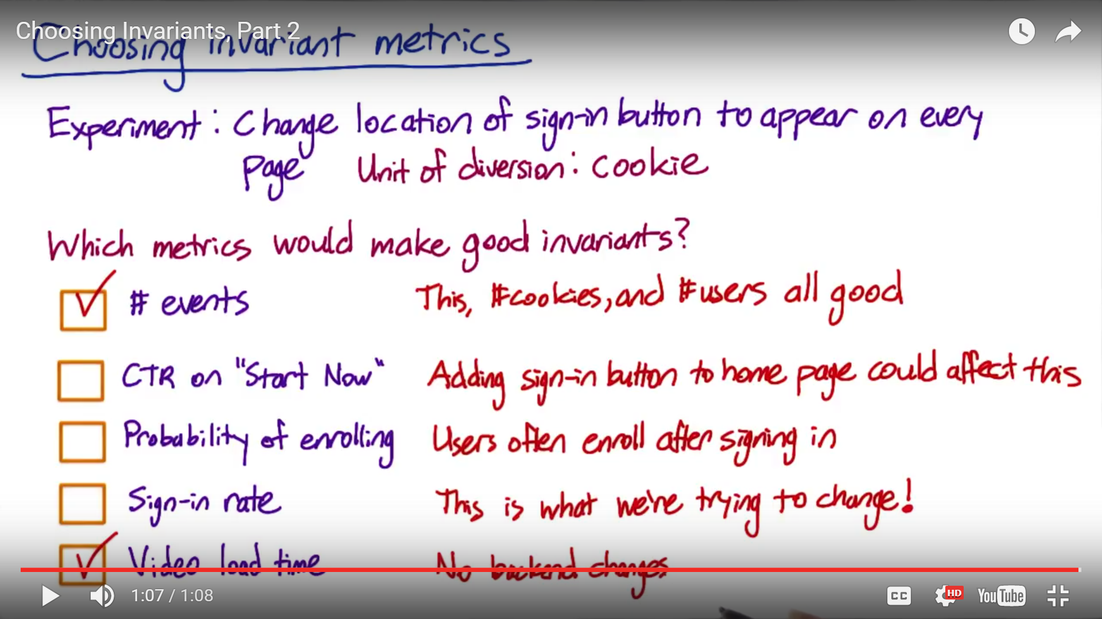

1. How to check whether the population size in control and experiment is different?

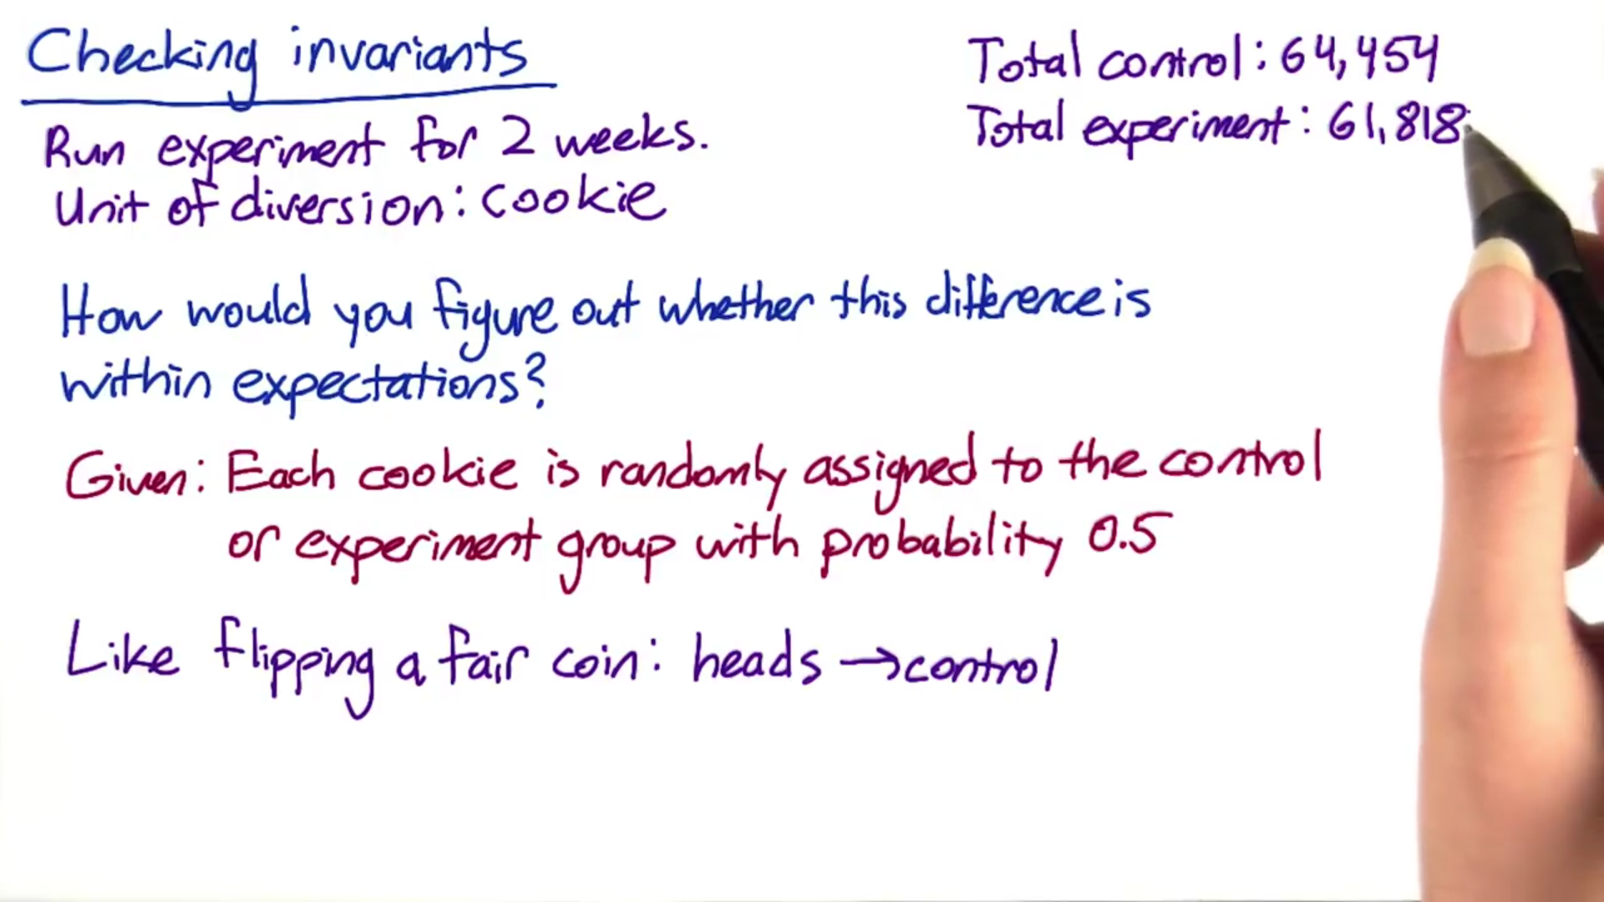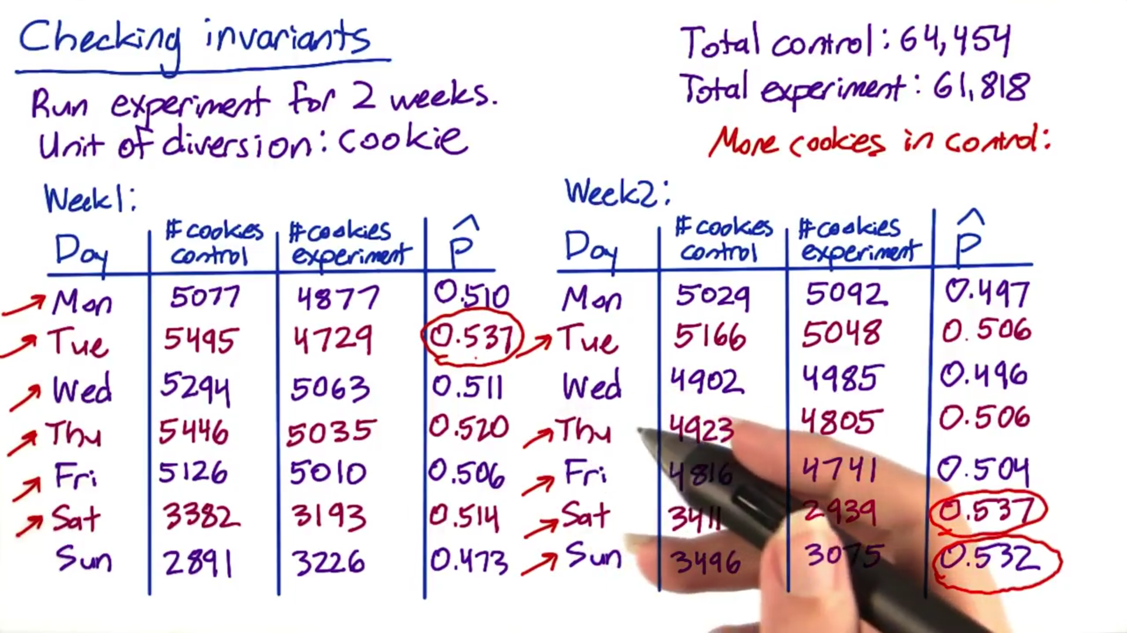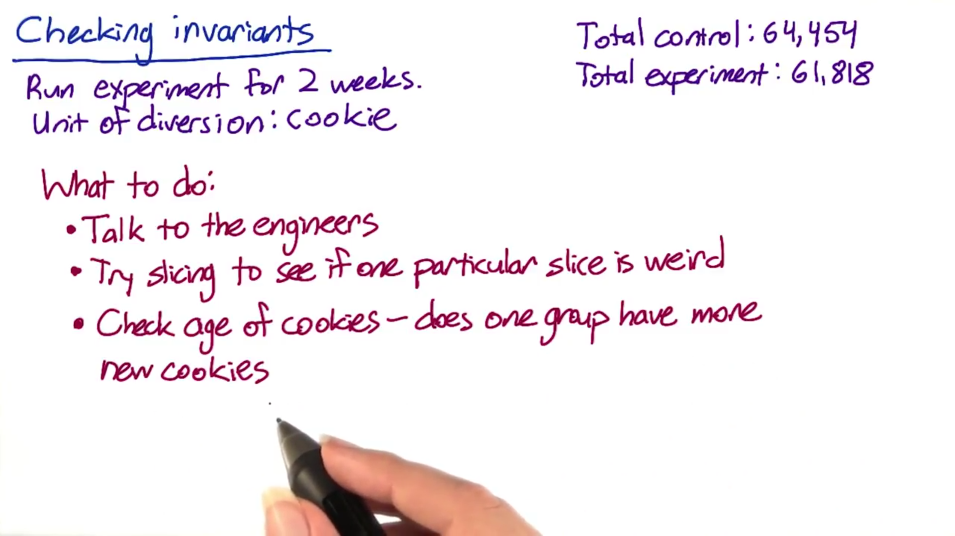G

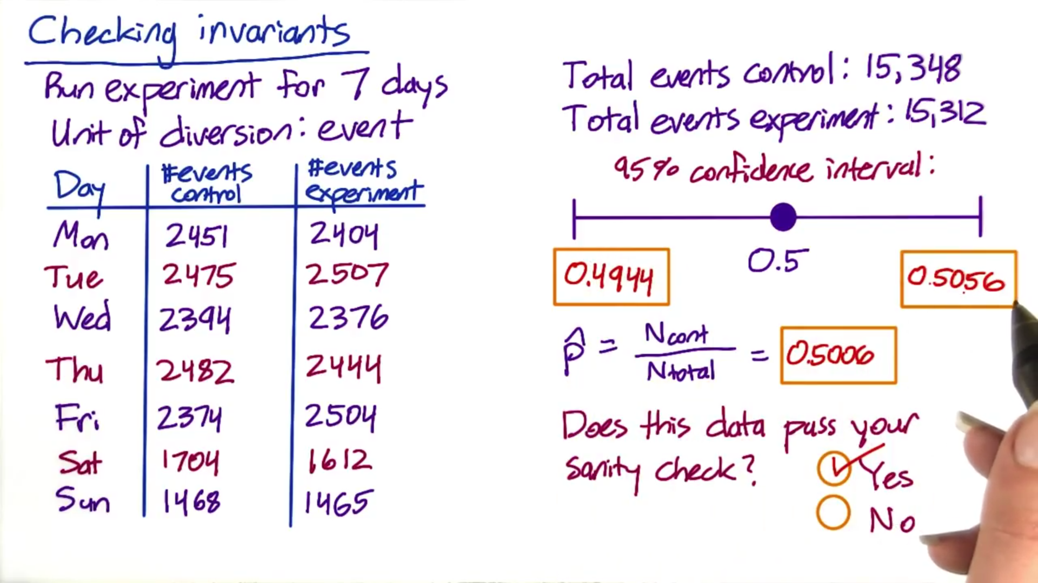

1. Goal is to make a business decision whether your experiment has favorably impacted your metrics, analytically that means that you want to decide if you have observed a statistically significant result of your experiment. Now, typically we also want to assess the magnitude and the direction of the change. Once you have all this information, you can recommend to the business whether they should launch this experiment. 
2. With CTR, the distribution is poison which is harder to deal with analytically (rather than binomial in case of CTP) so it would be a good idea to estimate the variance empirically. Audacity already computed the empirical SE of CTR (.0041) when they did the computation of the size required for the experiment. Now to compute the SE of the experiment we would use the relation between SE and sqrt(N), in this case with slight modification as we have 2 groups with slightly different pageviews
3. Confidence interval doesn’t include the practical significance boundary of 0.01 meaning I could be confident at 95% confidence level that the true change is large enough to be worth launching. However, let’s also look at the results of sign test and for that we would require day by day information (see below). To do the sign test, I would need the number of days and I also need to know the number of days with positive change so comparing the CTR across all days I observe that CTR is more in experiment across all 7 days. This certainly looks good for the experiment but what would be the change of it happening randomly. If there was no difference then there would be a 50% chance of positive change each day so the question is if you flip a fair coin 7 times what is the chance it comes up head 7 times. This is the same calculation I did earlier to do a population count sanity check. In the earlier scenario, I used a binomial distribution where each event was a cookie and the 2 outcomes were whether it gets assigned to a control group or experiment group. Here the event is a day and the 2 outcomes are positive change or negative change and the probability of each outcome is 50%. The main difference is that here we cannot use normal distribution since 7 days is not close enough for binomial to approximate normal. You can do the calculation by hand by using the probability density of binomial distribution but there is also an online calculator which you can use <http://graphpad.com/quickcalcs/binomial1.cfm> (here is the link for z score table <http://www.stat.ufl.edu/~athienit/Tables/Ztable.pdf> )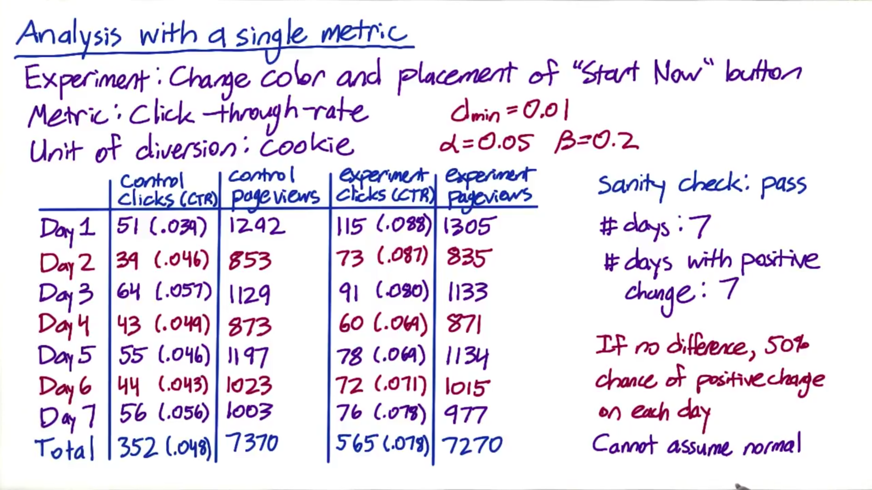

 

1. Number that I’m interested in here is the two-tail P value which is 0.0156, that’s the probability of observing the result atleast this extreme by chance. Since this is less than chosen alpha of 0.05 the sign test agrees with the hypothesis test that this result was unlikely to have come by chance. Given this I would definitely launch the experiment with increased confidence

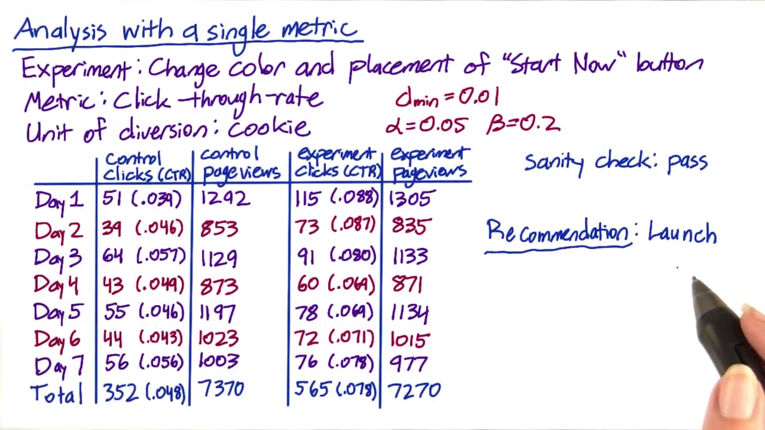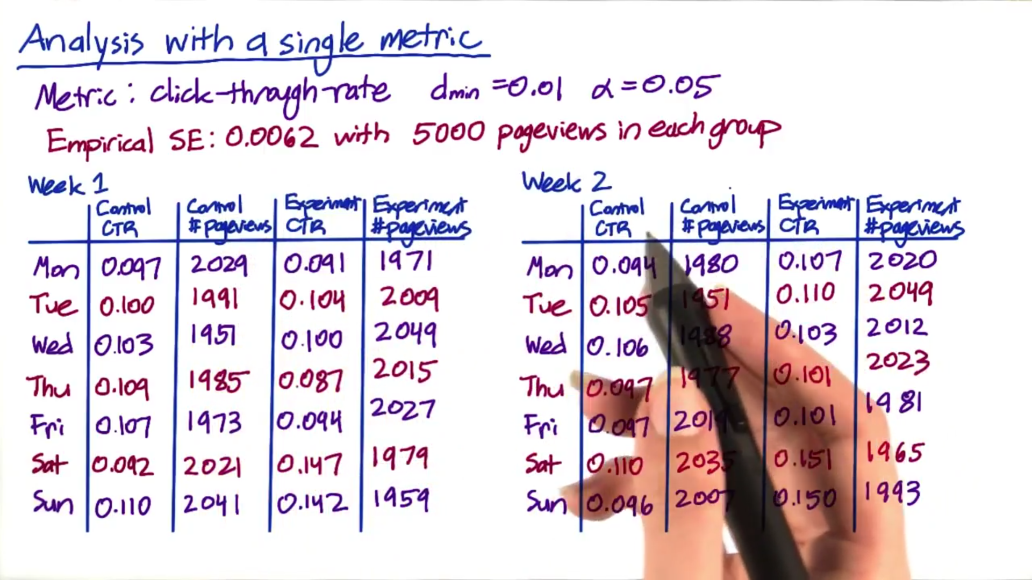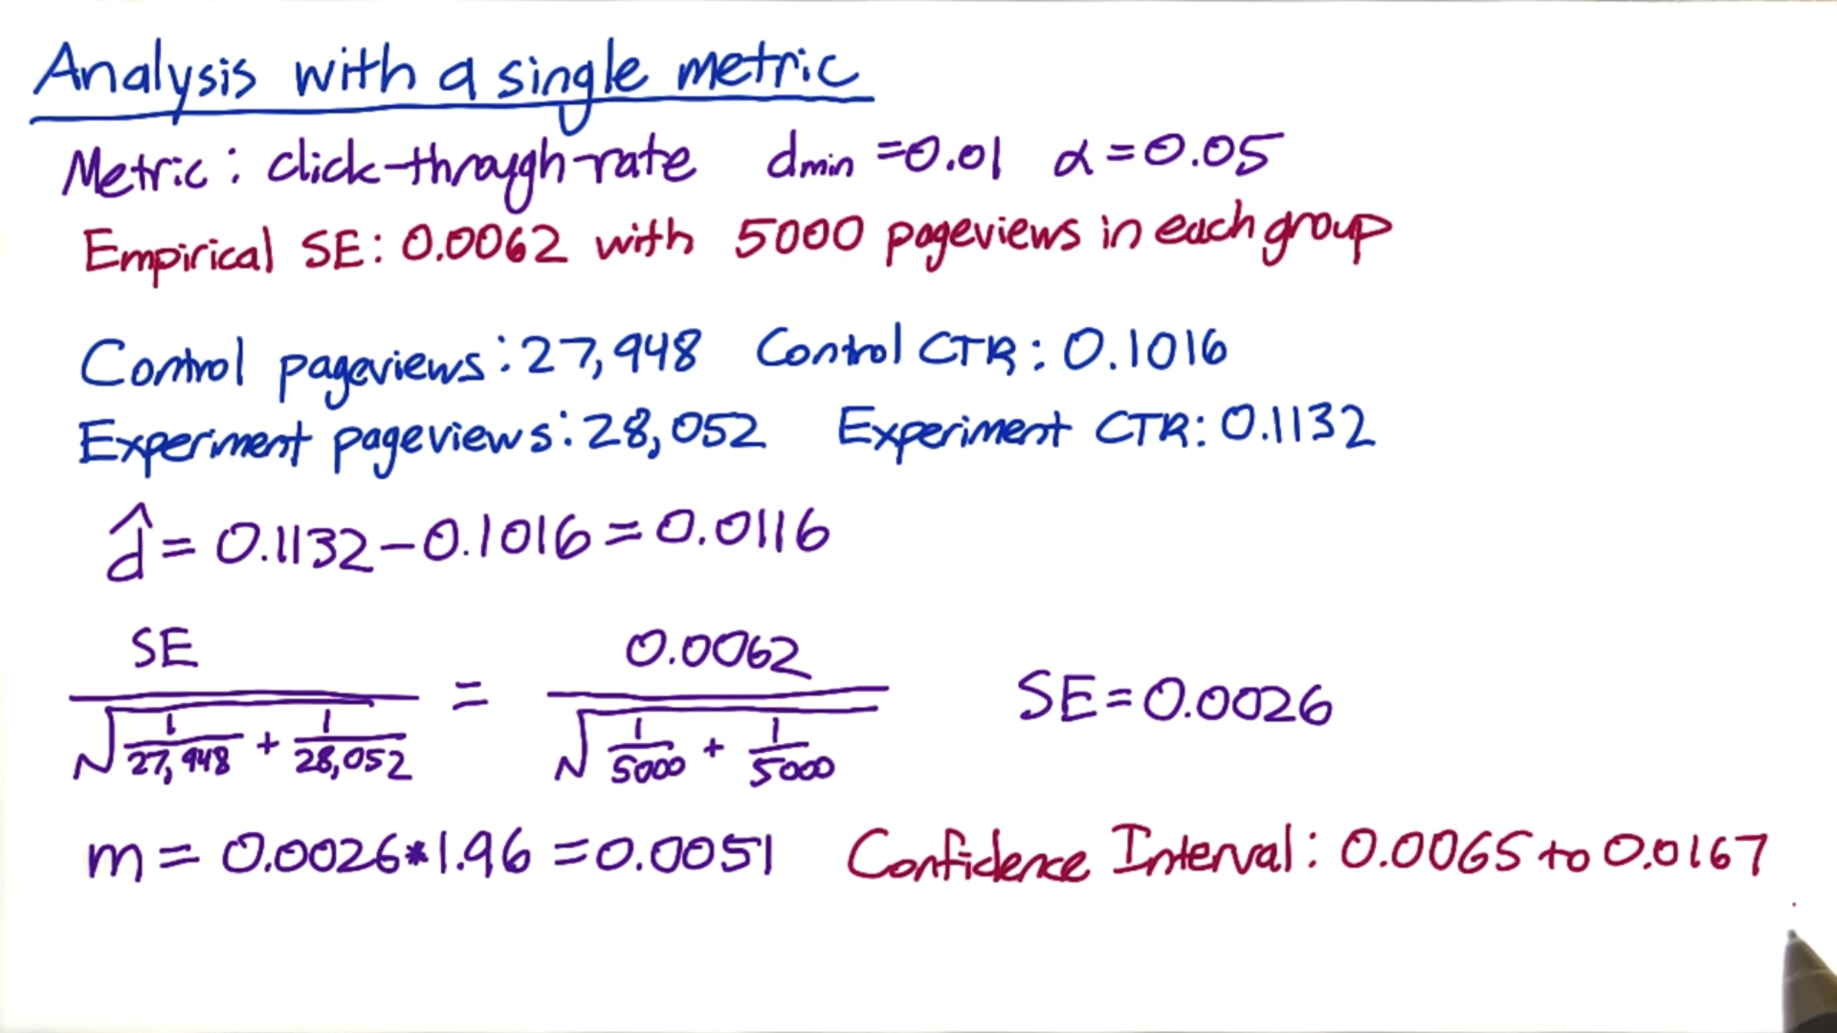

1. In above snapshot, confidence interval doesn't include 0 which means results are statistically significant i.e. it is unlikely that there was no real difference….. However, the confidence interval does include the practical significance level boundary(0.01) meaning that I can't be confident at the 95% confidence level that the size of this effect is something that I care about.

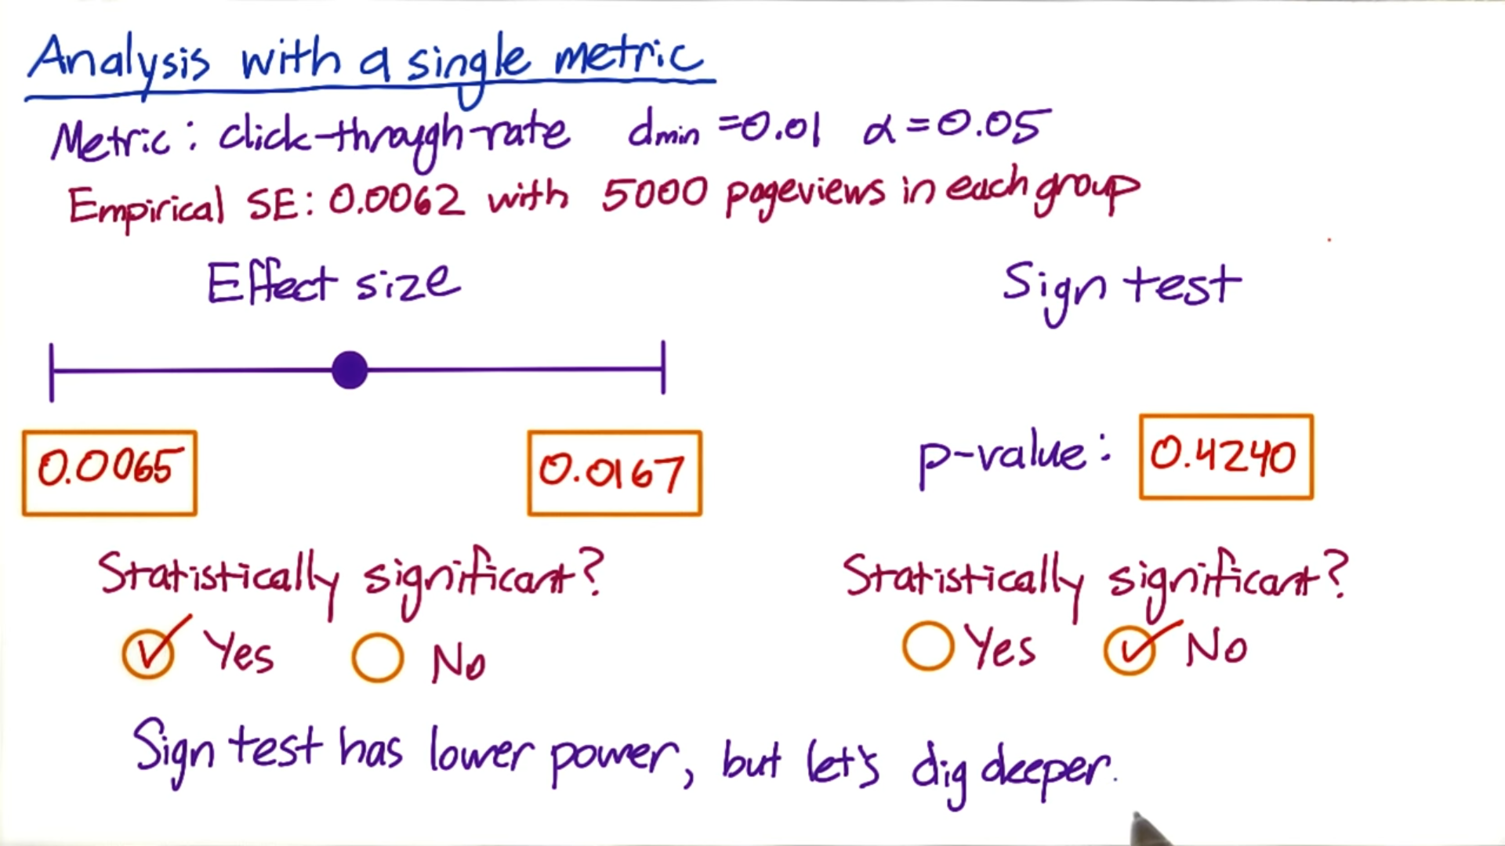

1. In above snapshot, sign test is not significant …. This is usually not a red flag as sign test has low power (this is usually the case with non parametric tests) but still let's dig deeper

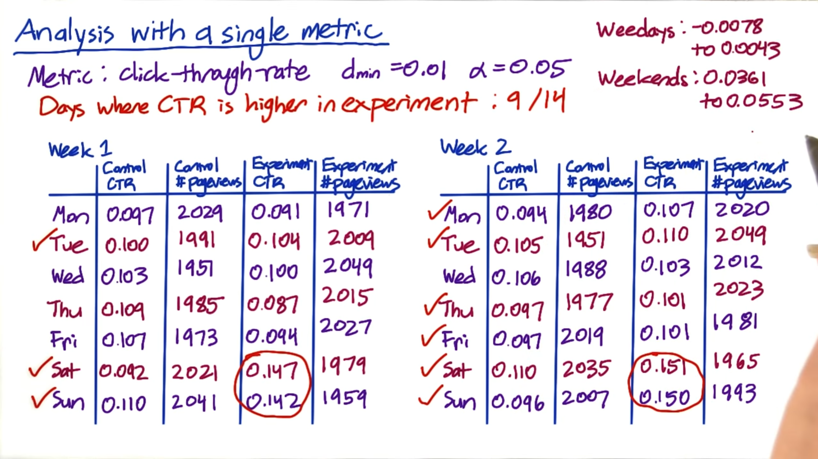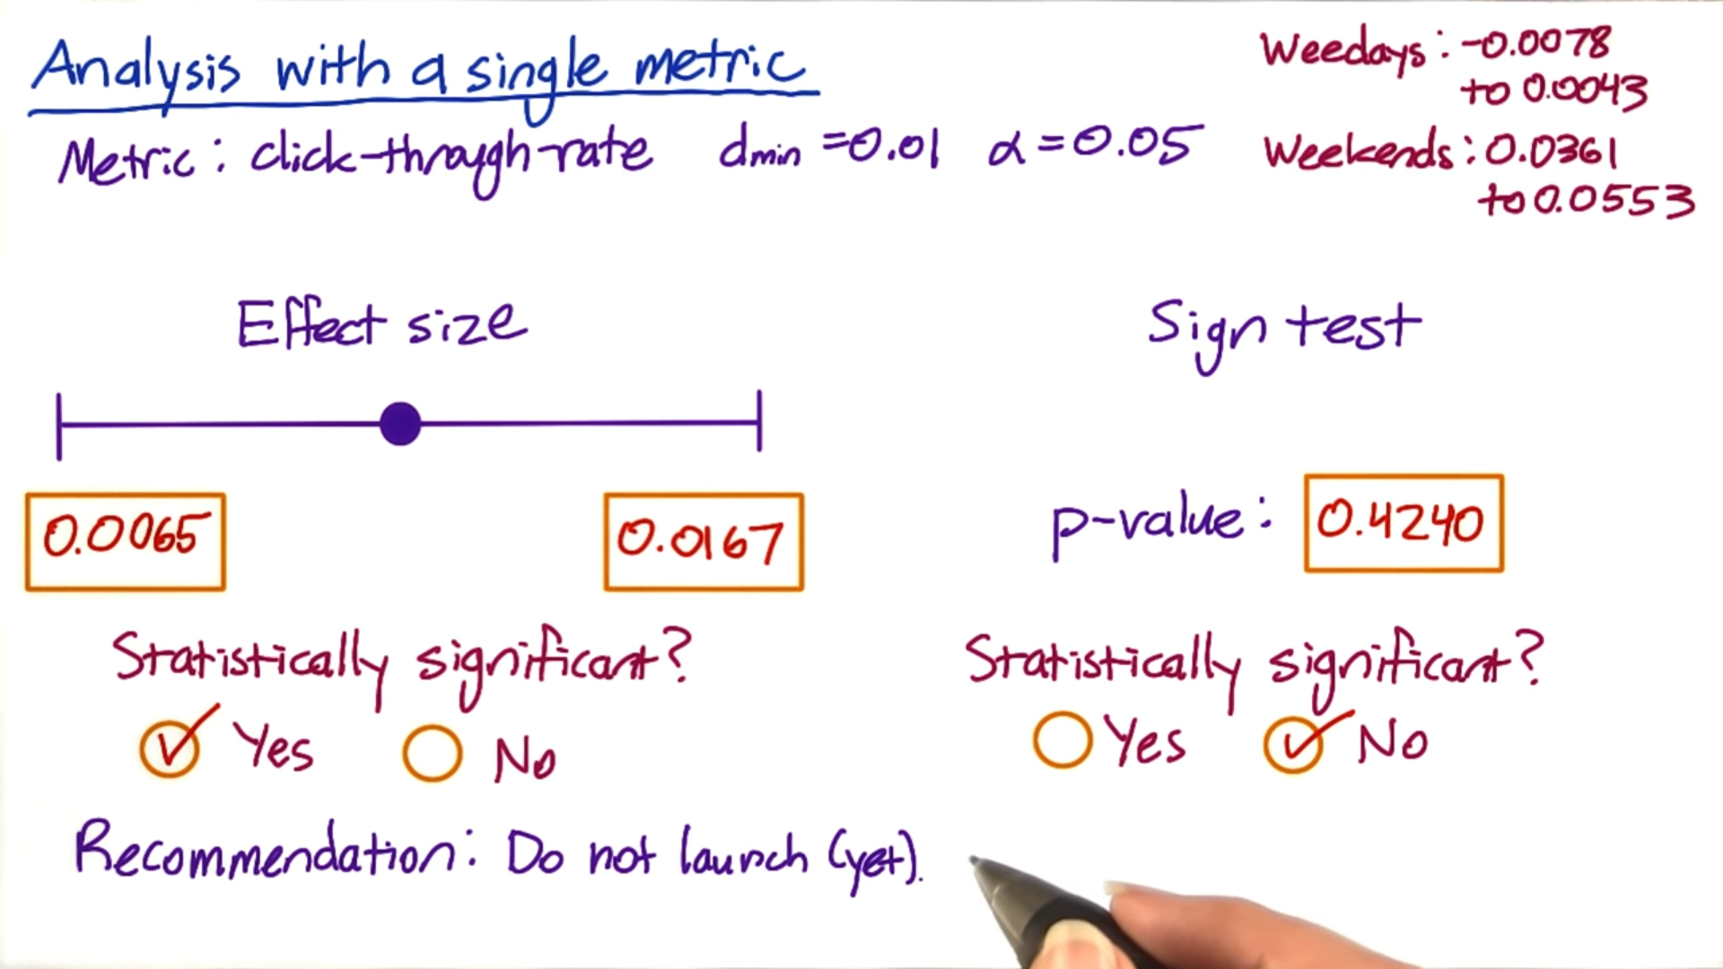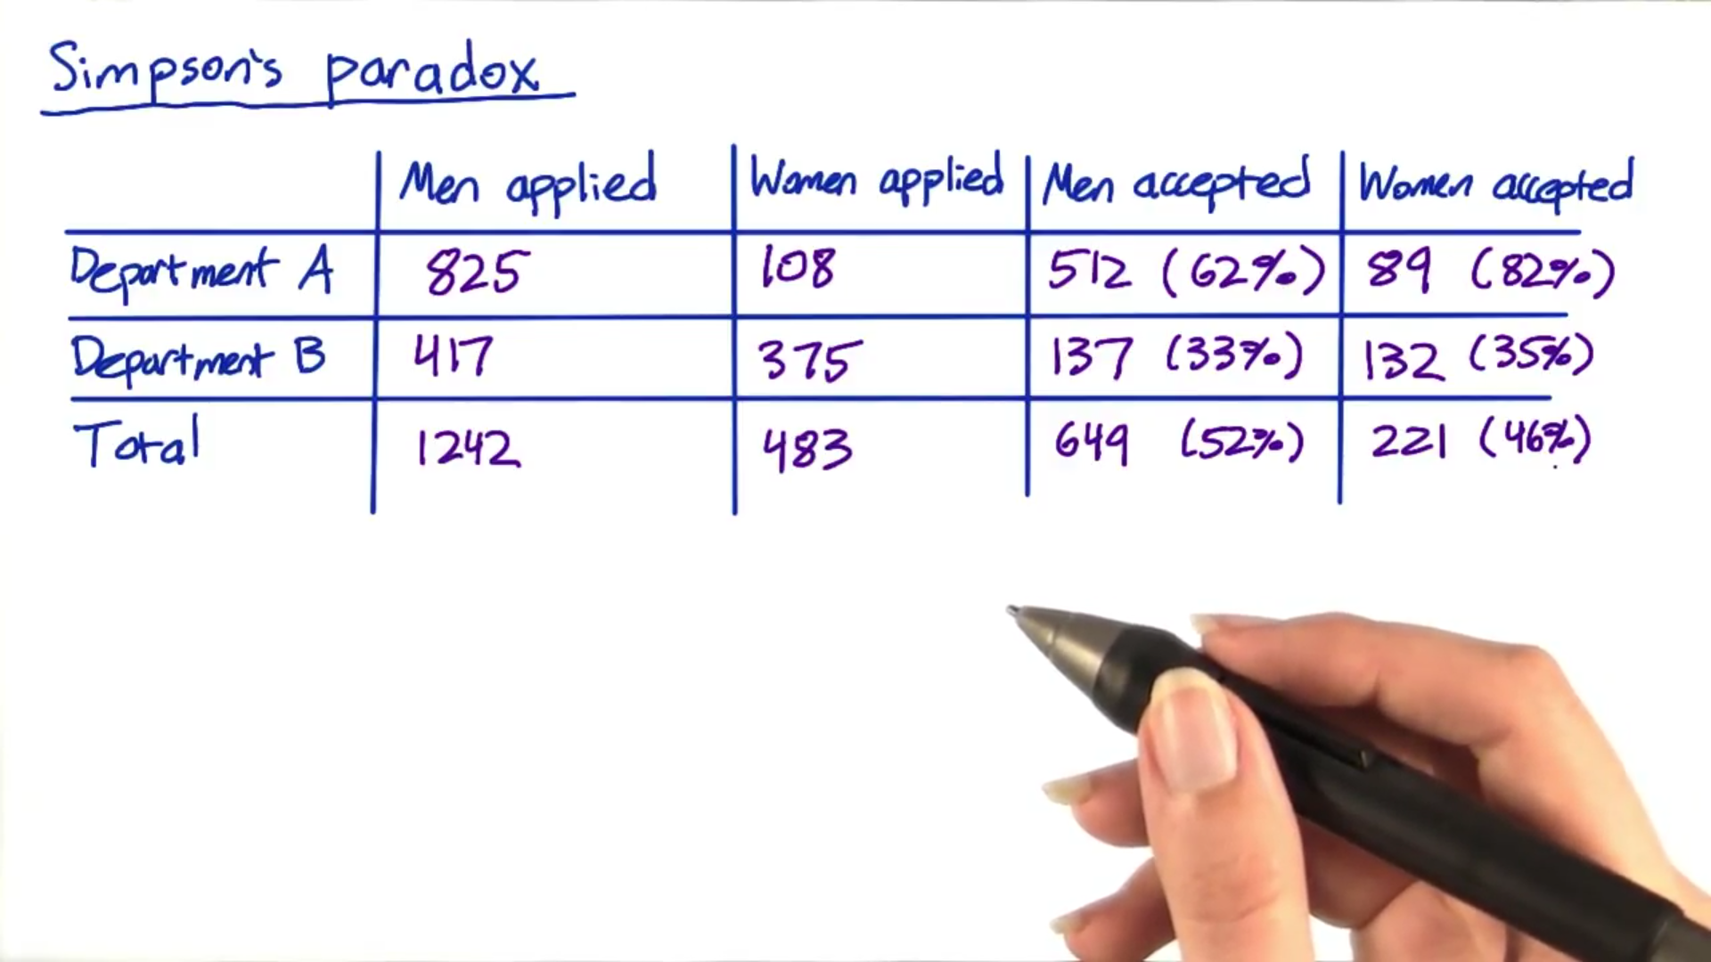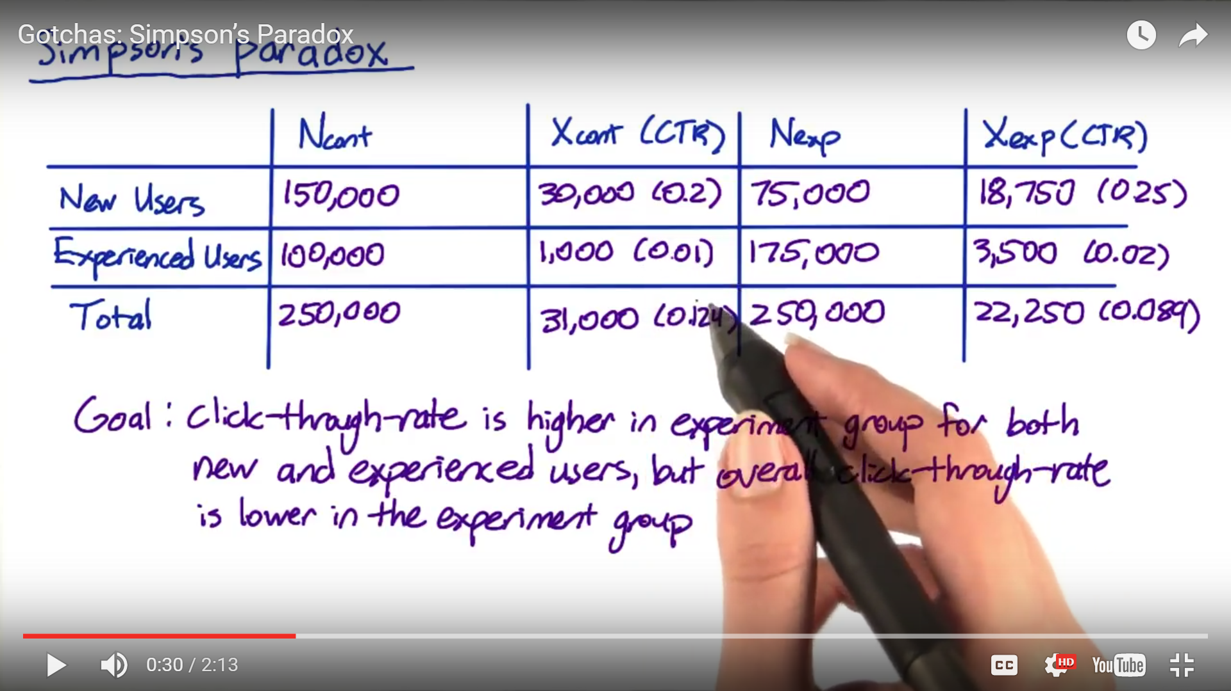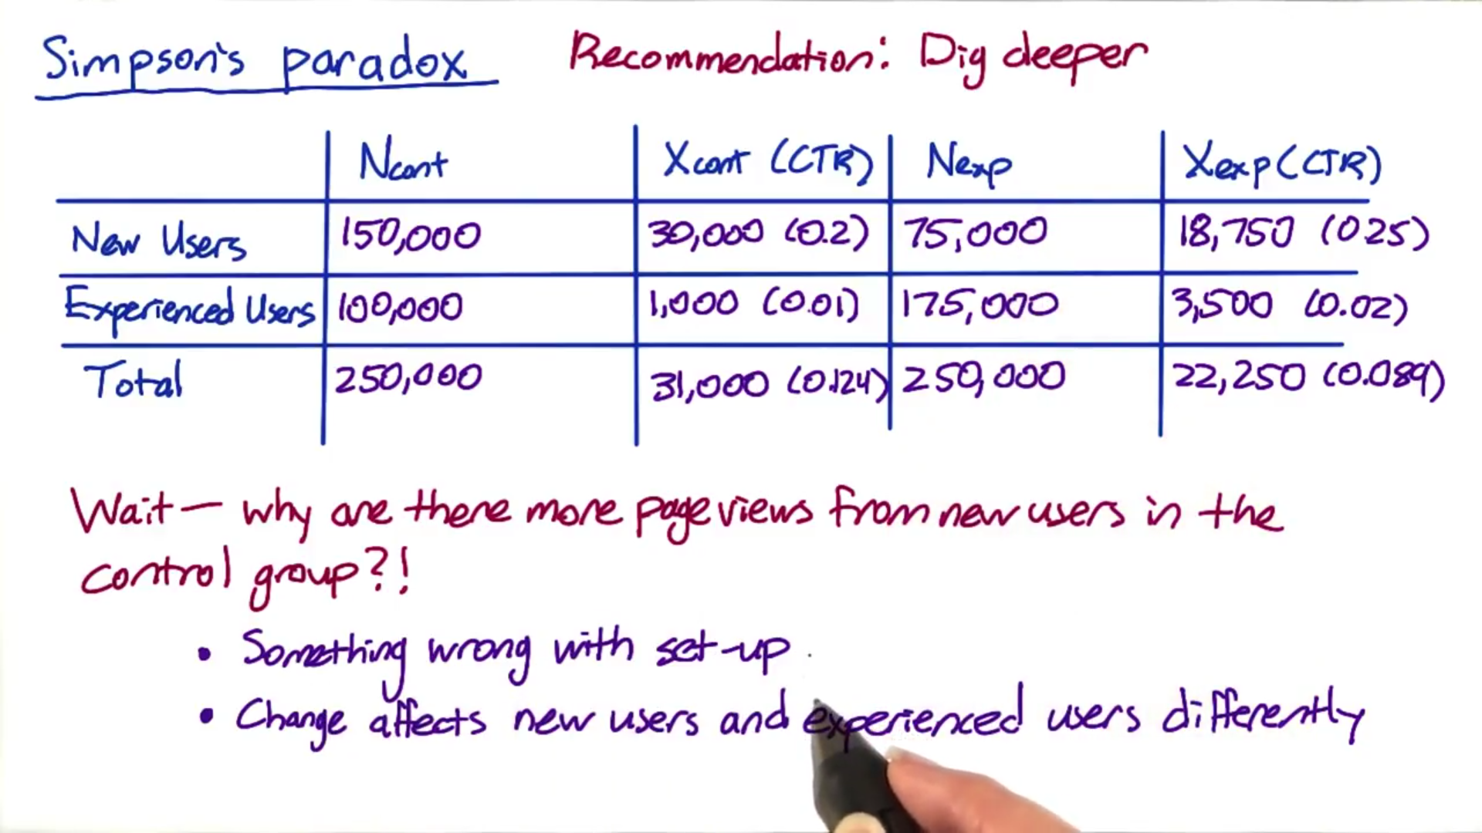

1. When you run a evaluation of multiple metric at the same time, is it the more things you test the more likely you are to see a significant differences just by chance so if you are testing 20 metrics and you have a 95% confidence interval level, you would expect to see 1 case atleast where you a result where it says it is significant but it’s only occurring by chance so this is a problem but you are not sunk because it shouldn’t be repeatable. i.e. if you did the same experiment on another day or divided the data by different slices or you did some bootstrapping analysis you wouldn’t see the same metrics showing up as significant differences every time, it should occur randomly. There is another technique for this called multiple comparisons that adjust your significance level so that it accounts for how many different metrics or how many different tests you are doing. 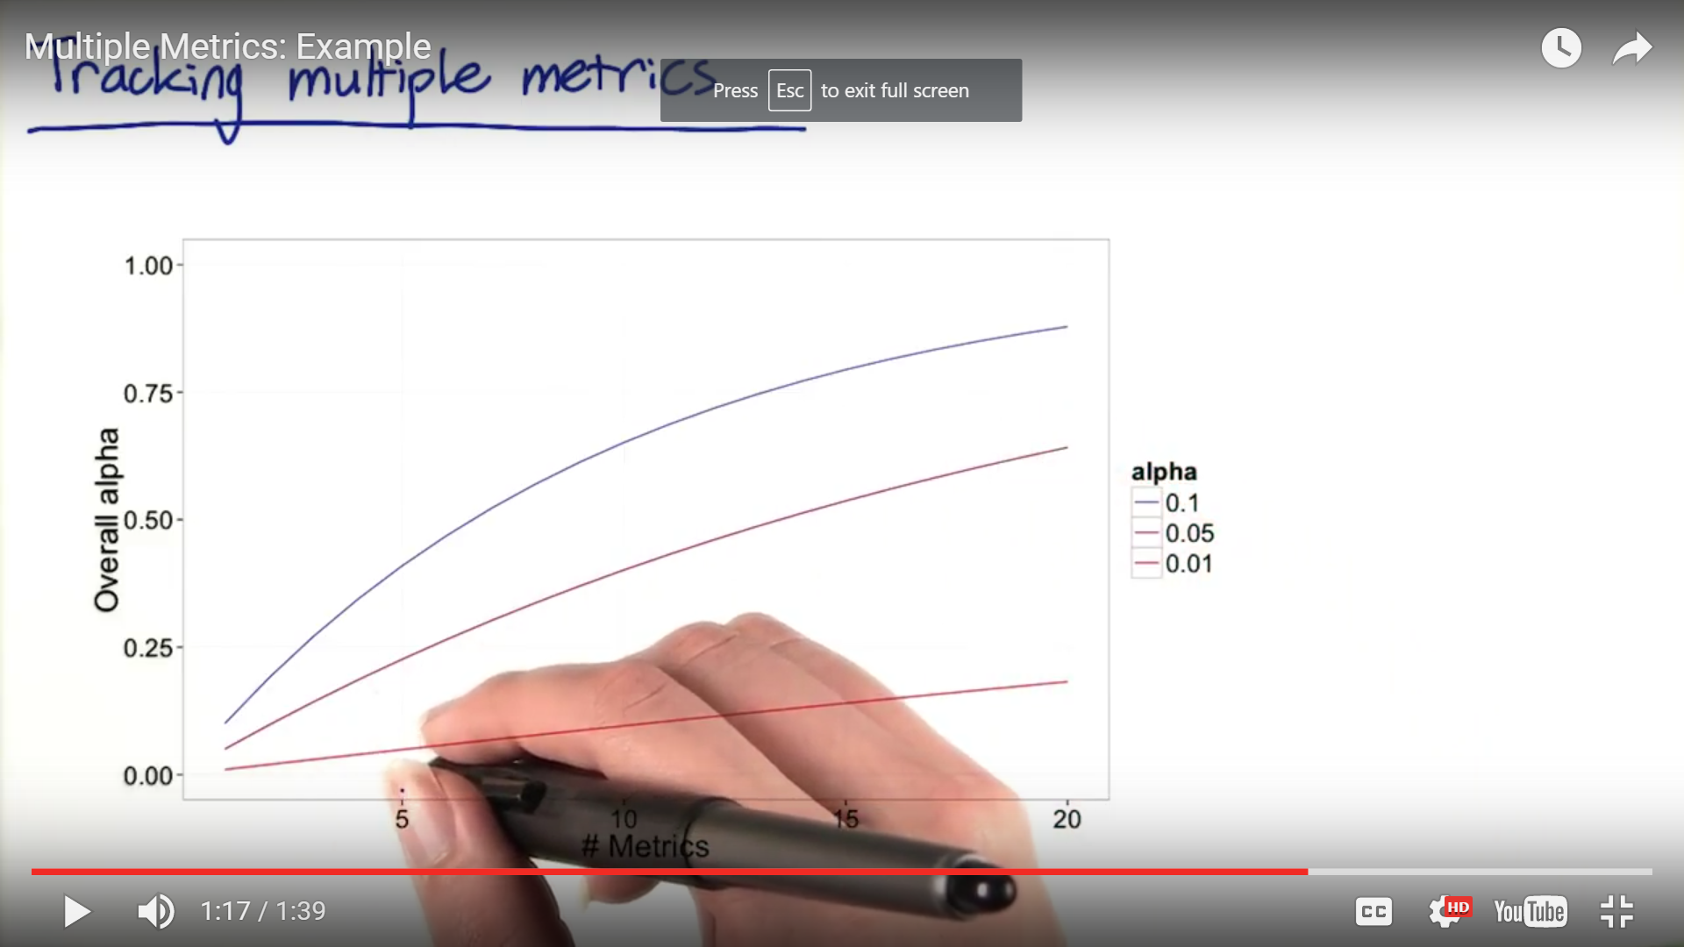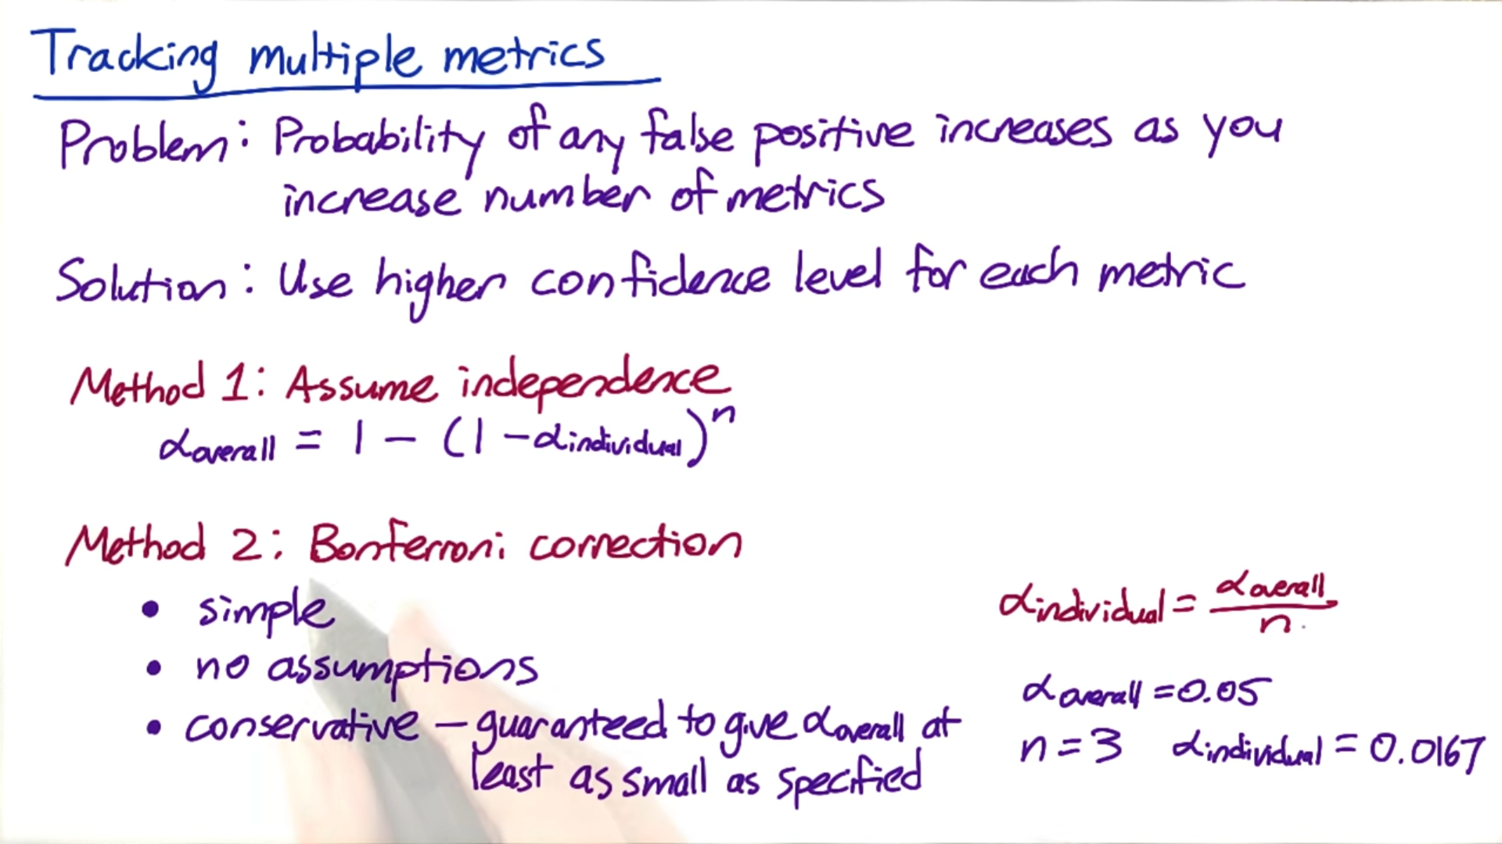
2. The main problem with Bon Ferroni method is that often you will be tracking metrics that are correlated and all tend to move at the same time in which case this method is too conservative i.e. probability of false positive rate would be higher than reality which would make the business launch fewer experiments than they would like.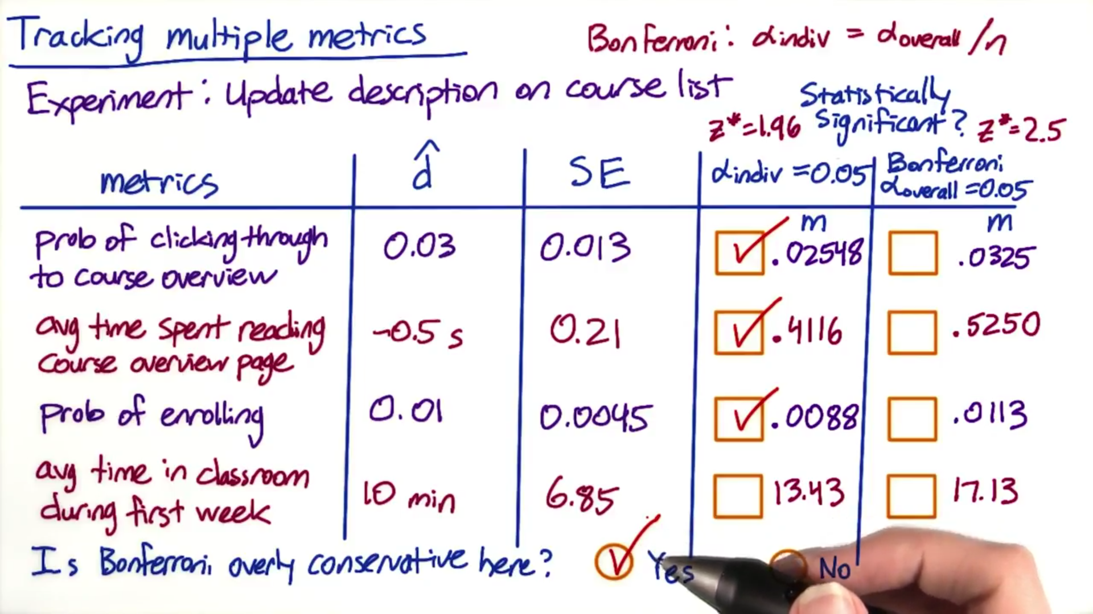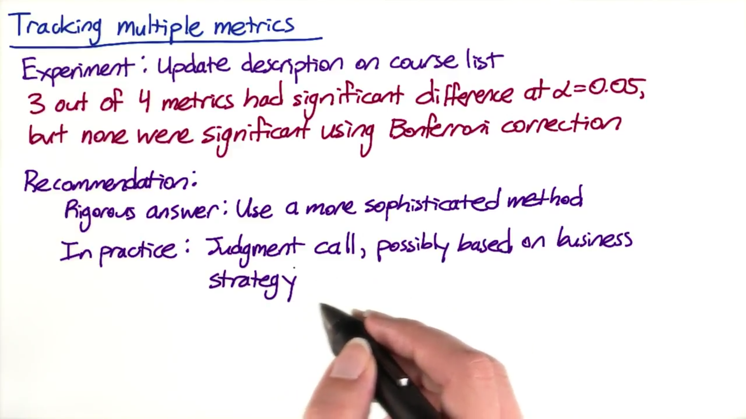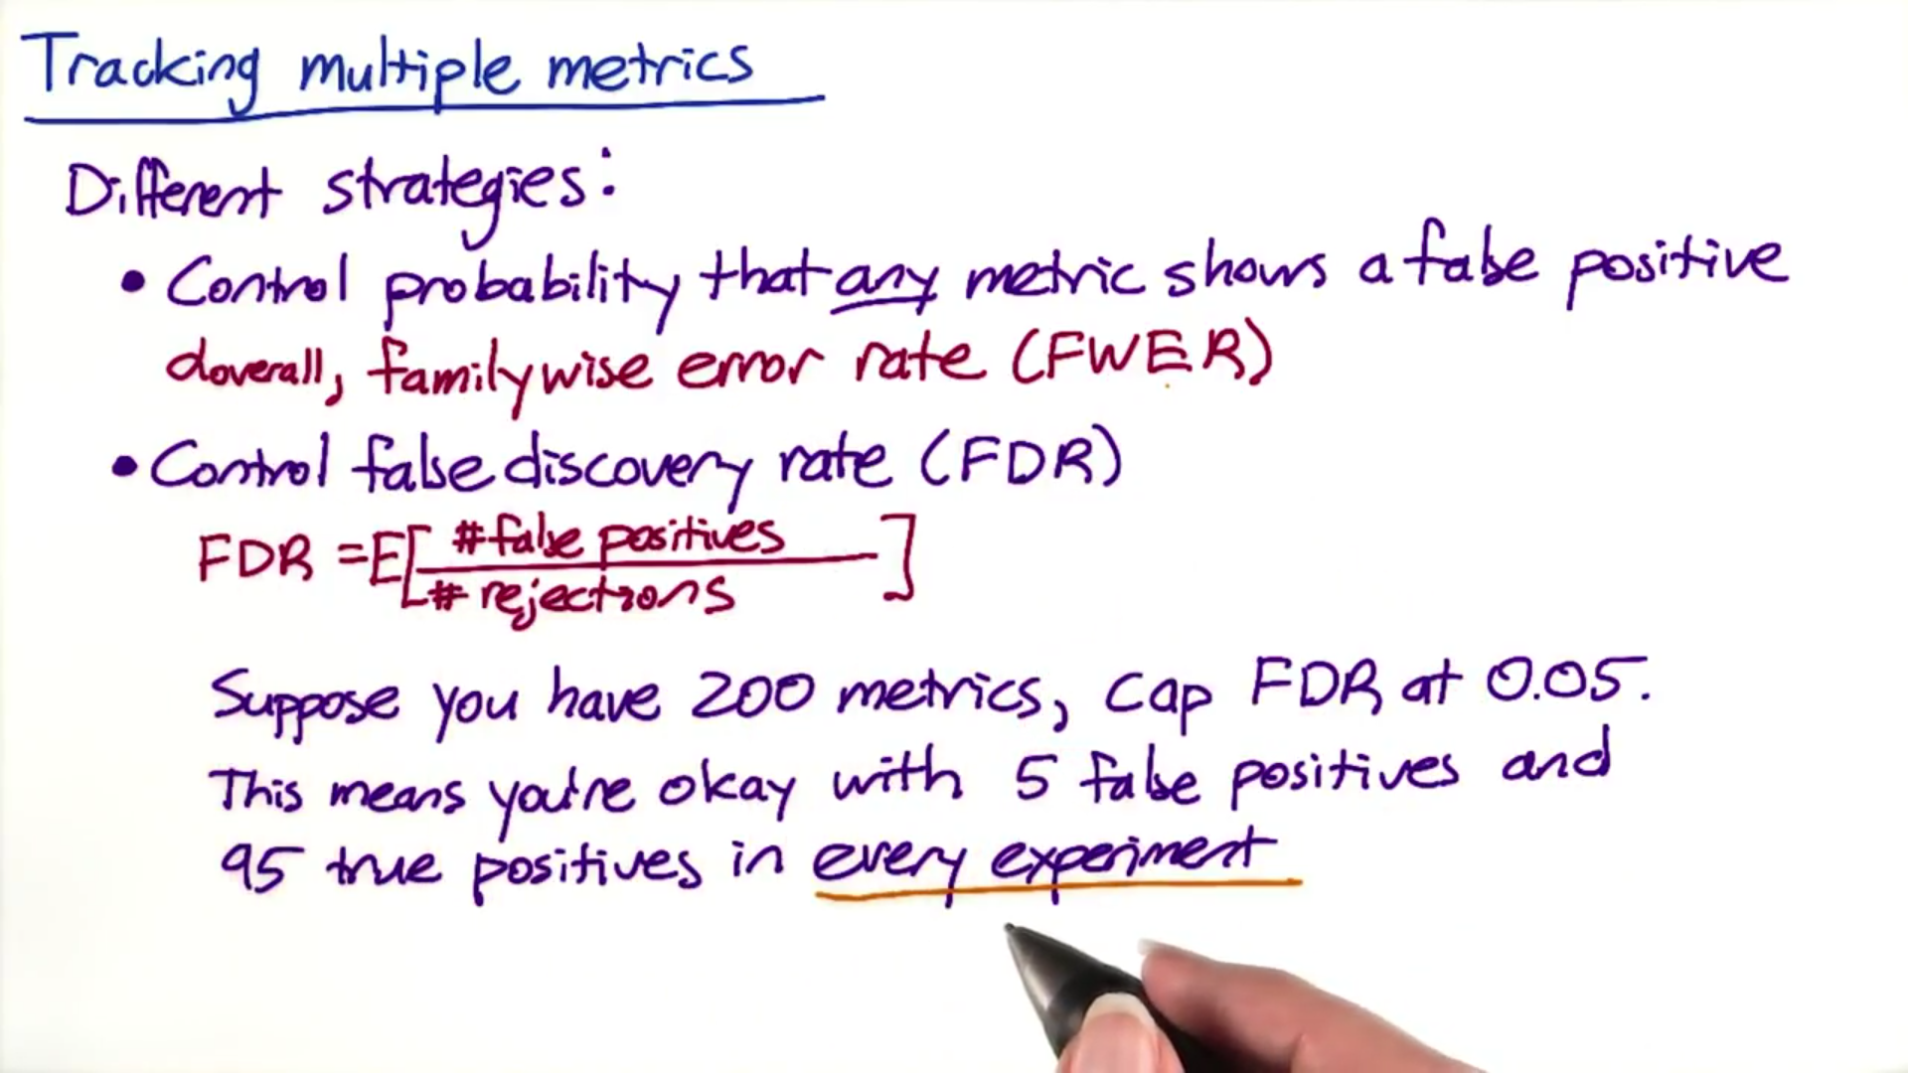
3. Less conservative multiple comparison methods  
   The Bonferroni correction is a very simple method, but there are many other methods, including the closed testing procedure, the Boole-Bonferroni bound, and the Holm-Bonferroni method. This article on multiple comparisons contains more information, and this article contains more information about the false discovery rate (FDR), and methods for controlling that instead of the familywise error rate (FWER).
4. When you have multiple metrics:
   1. You would hope that related metrics move in the same direction (ex- CTR & CTP)
   2. When you have a composite metric like RPM (revenue per thousand queries which is composed of both CTR as well as cost per click) and so if you see RPM move in 1 direction, hopefully you can look at CTR and CPC to understand why it is moving in certain direction
   3. You should balance the long term investment like return visits to the site with short term day to day metric like increased clicks. You don’t want to loose 1 in pursuing the other 1 so often the best OEC gives you a good balance between those 2 things.
      1. Typically there is a lot of validation in the process of coming up with OEC but usually you start off with some kind of business analysis. So you might say that our company as a whole might look at 25% revenue + 75% increased usage of the site so usually you start from this and once you have bunch of candidates you run a whole bunch of experiments and validate how they steer you, are they steering you in the right direction. Now the down side is that you want to make sure that you don’t plan so much around what the company think should happen with those experiments that you steer yourself in a way that you hide the other changes that you weren’t expecting
5. **Others:**
   1. You should't look at the result continuously and decide the size/significance
   2. With click-through rate, the distribution would be poisson rather than binomial (click-through probability) which is harder to deal with, so it's a good idea to estimate the variance empirically……….